# APPENDIX A1: Gantt Chart of the Project

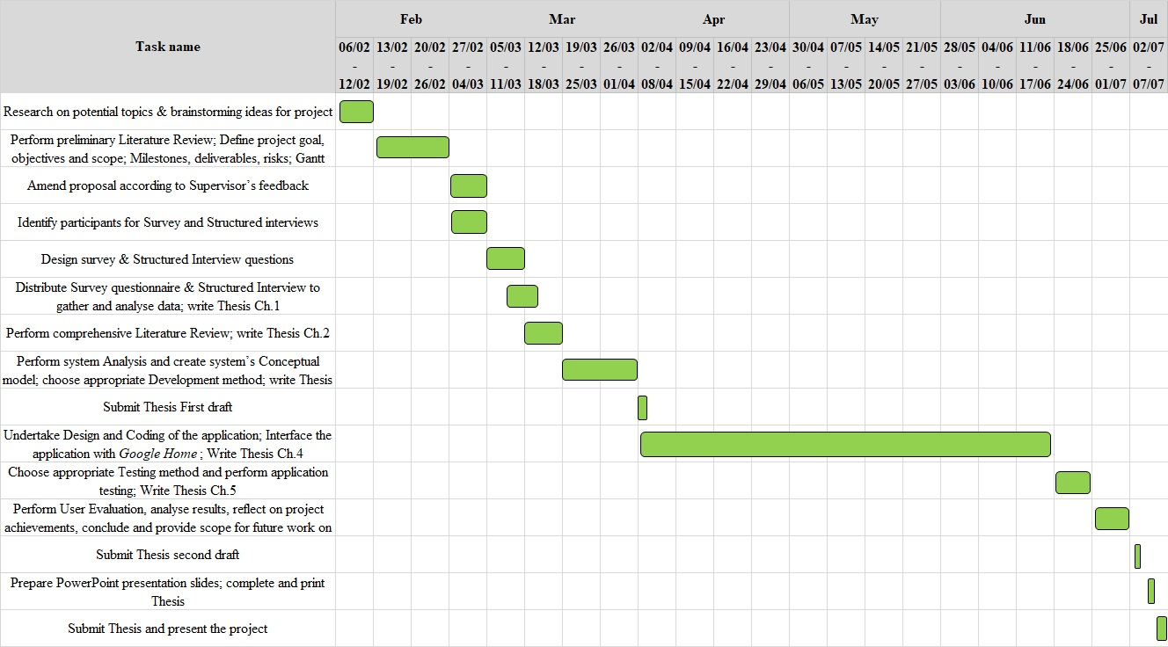

# APPENDIX A2: Graphical Representation of the Potential Adopters Survey Results

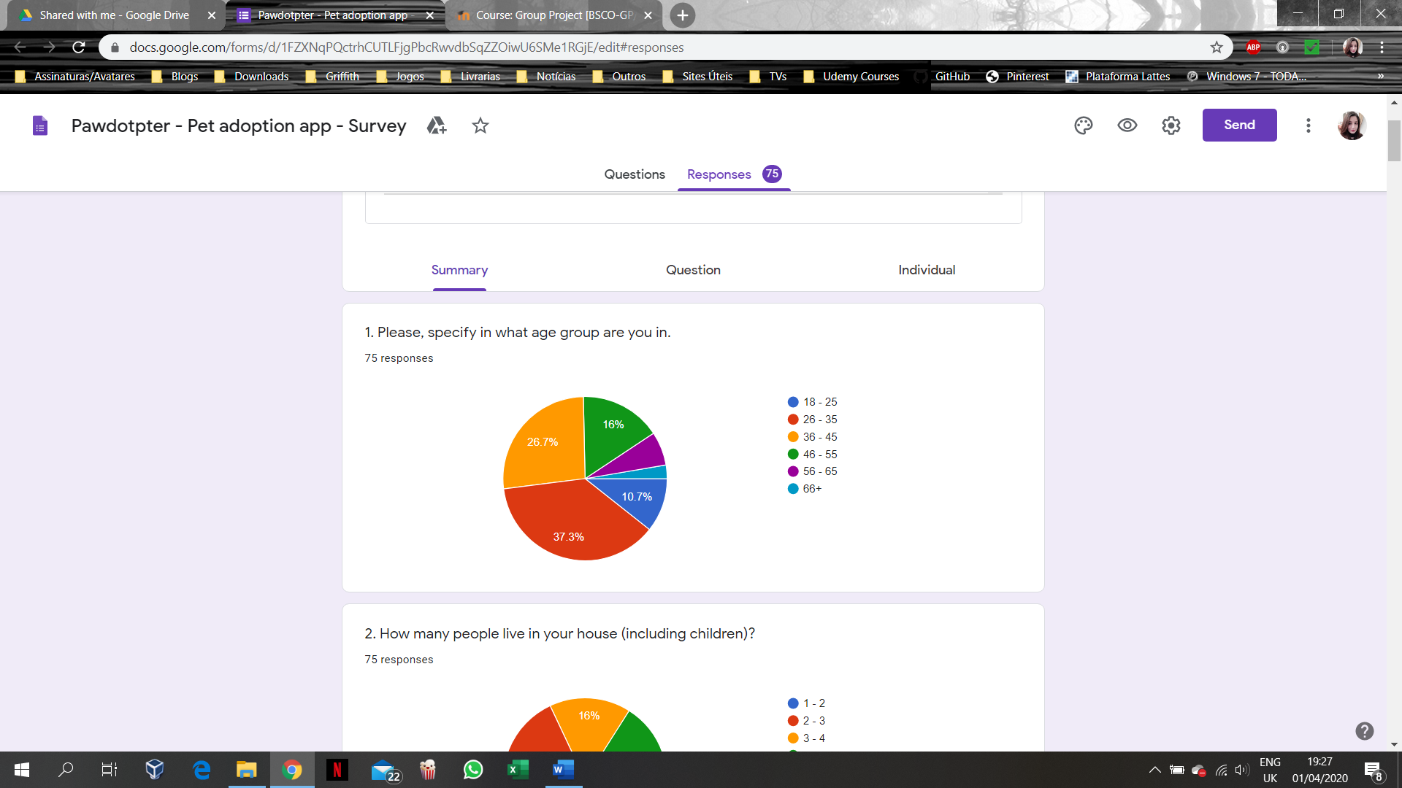

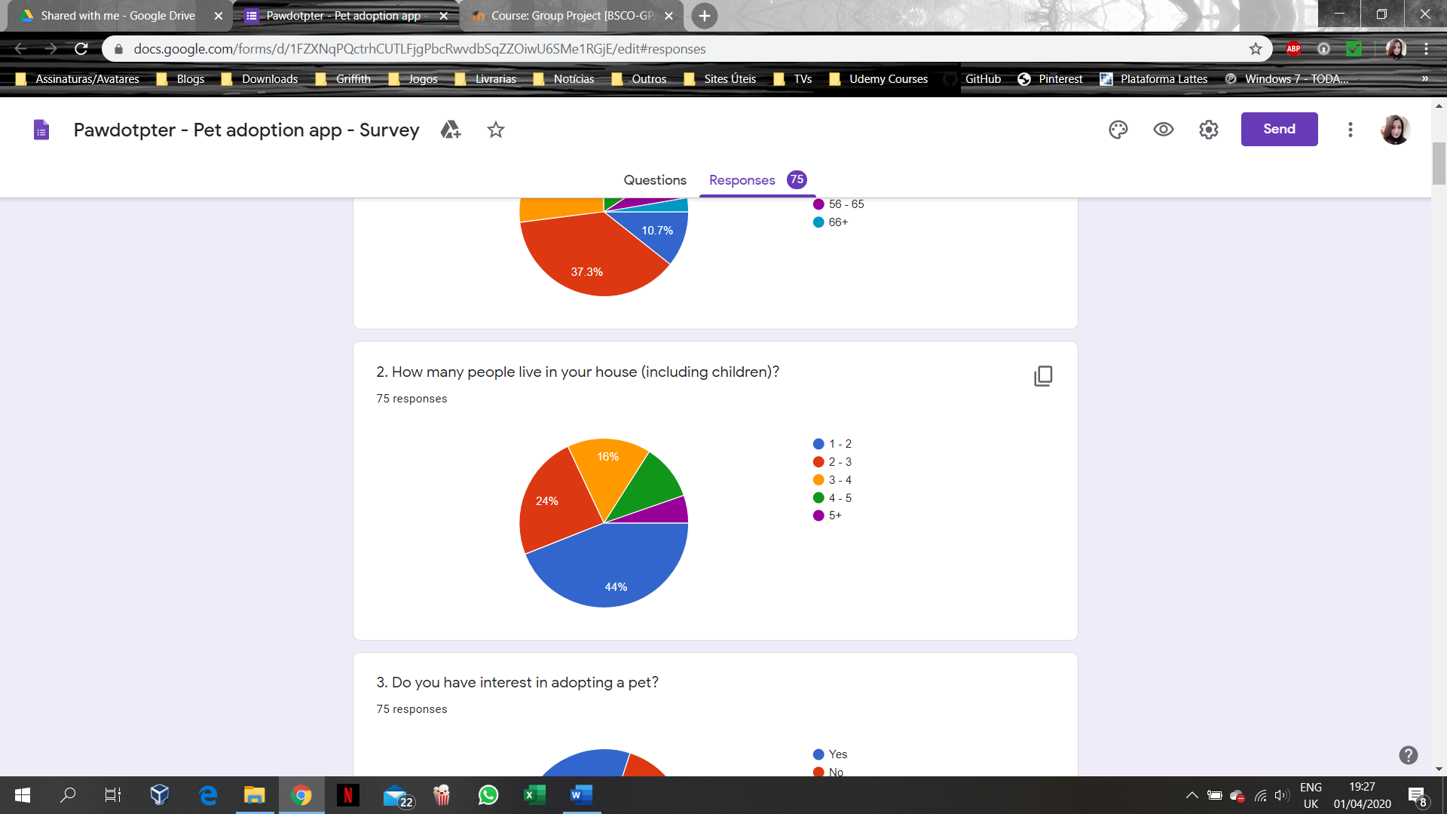

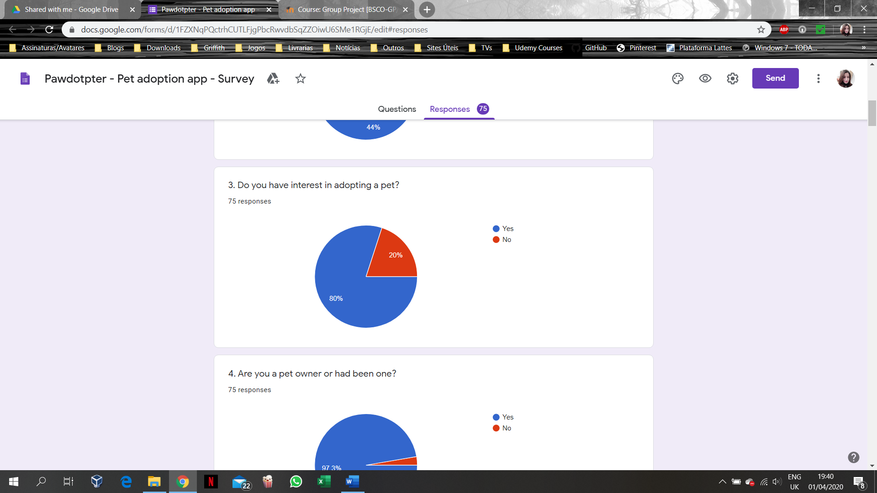

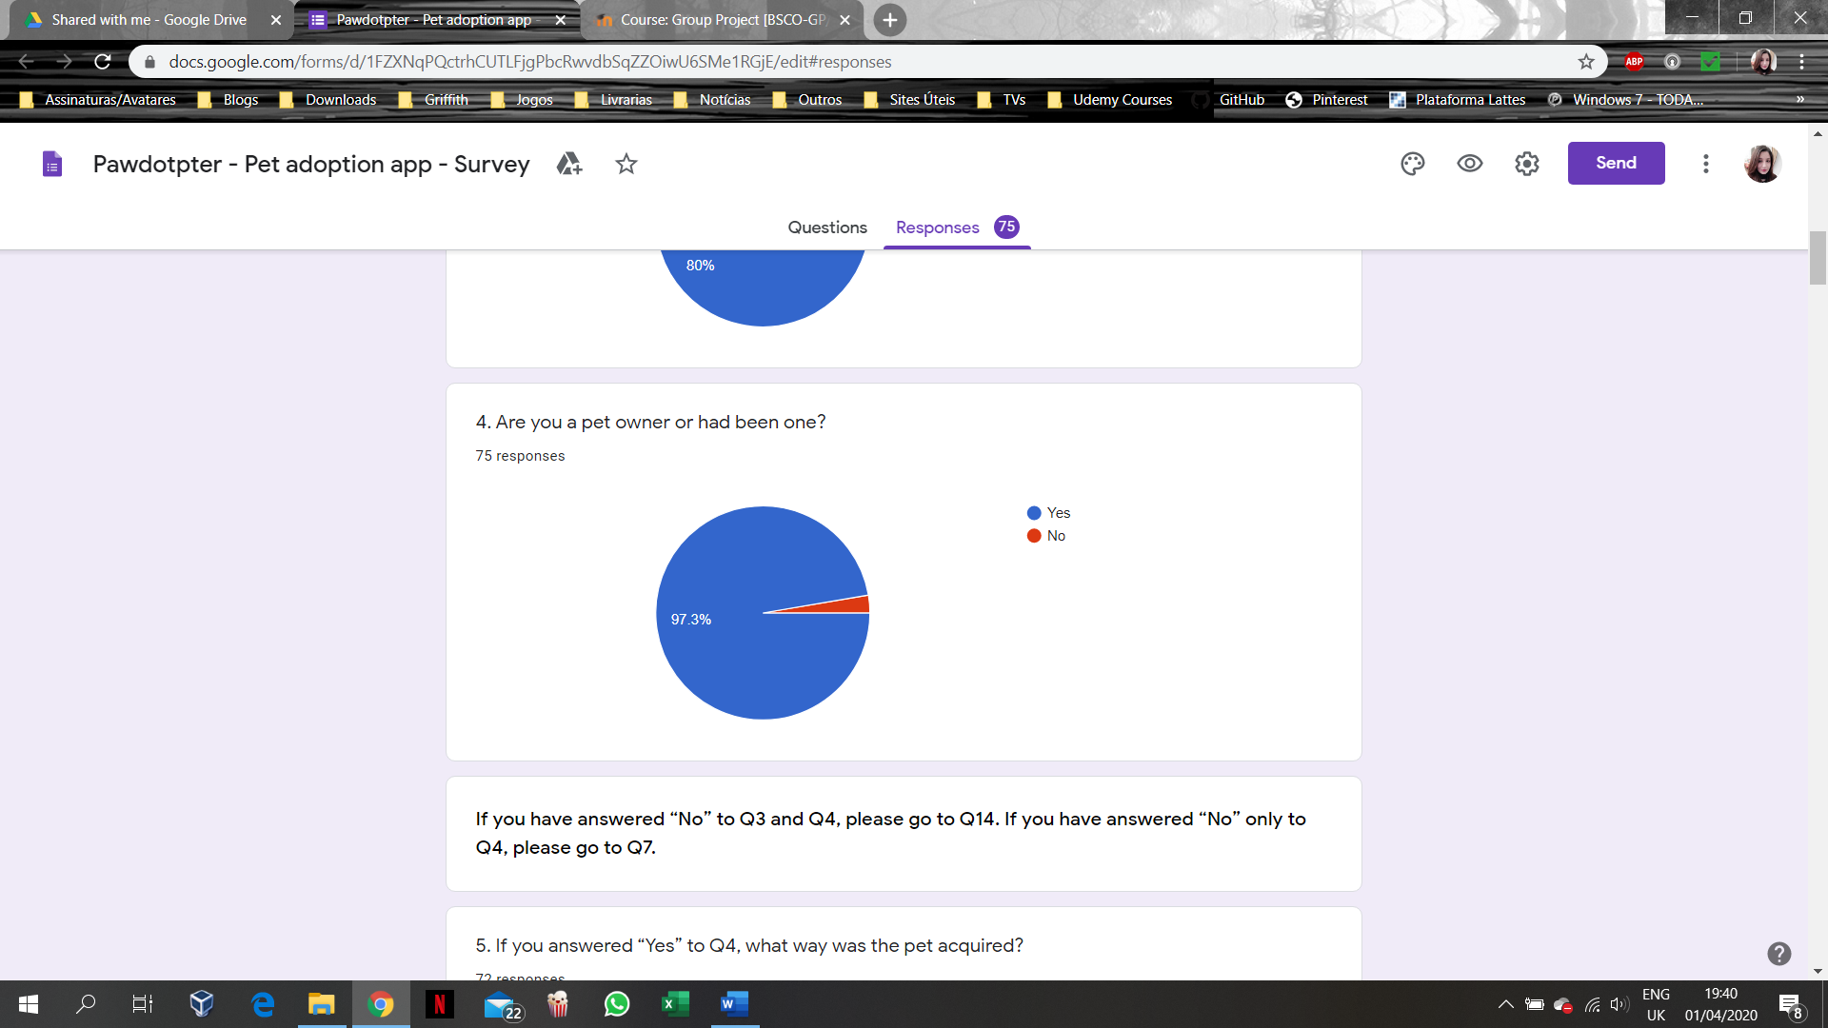

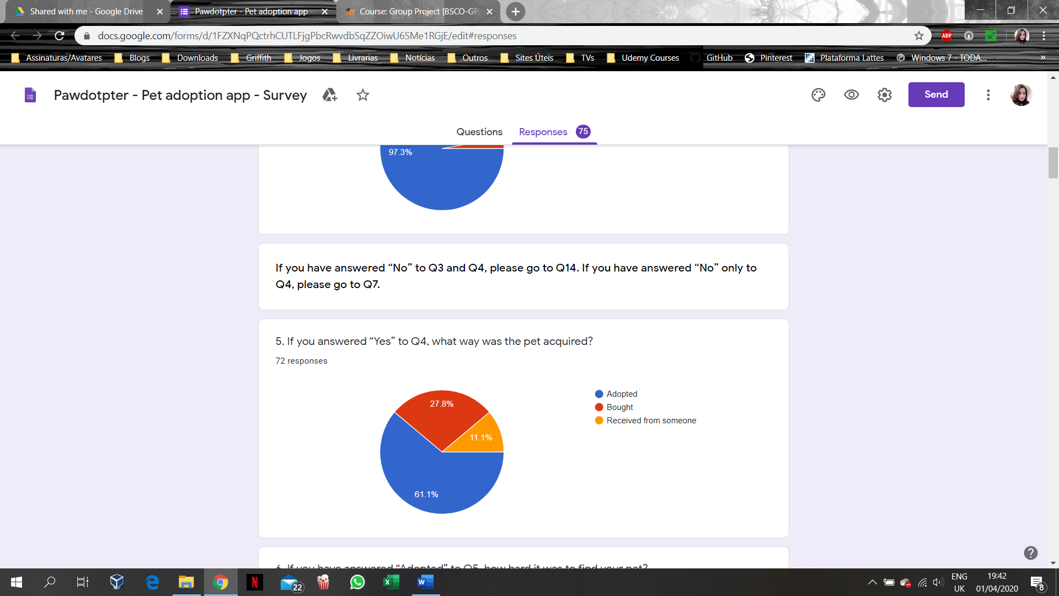



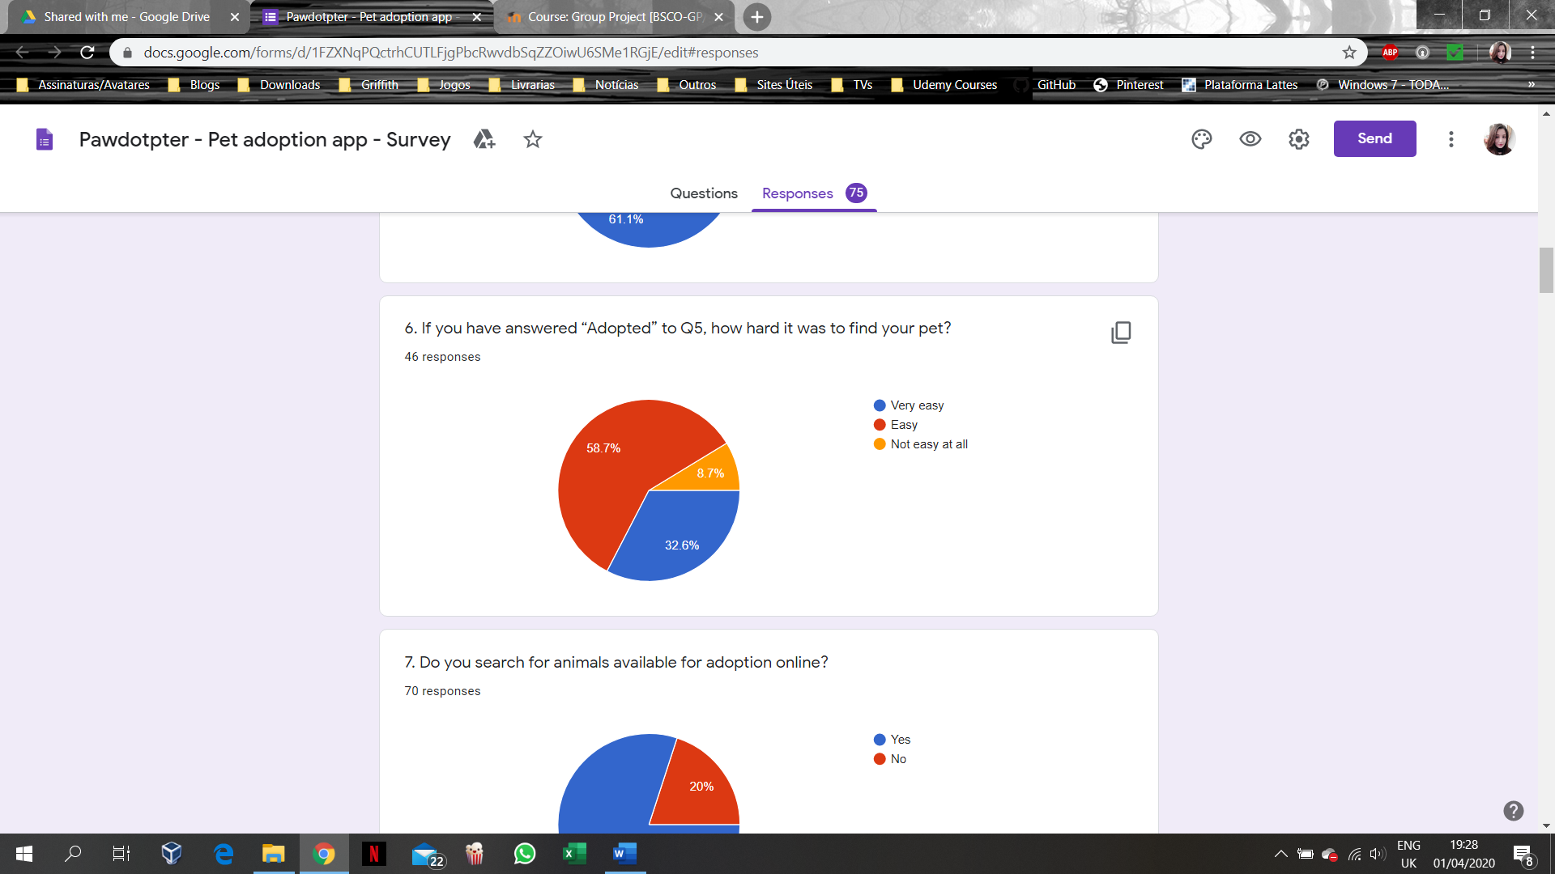

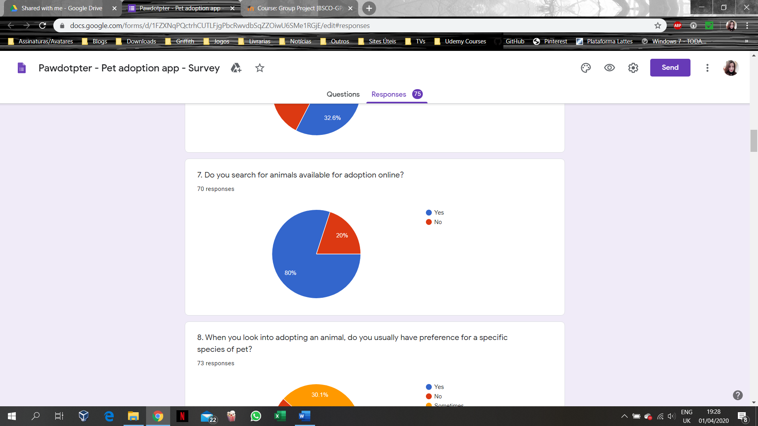

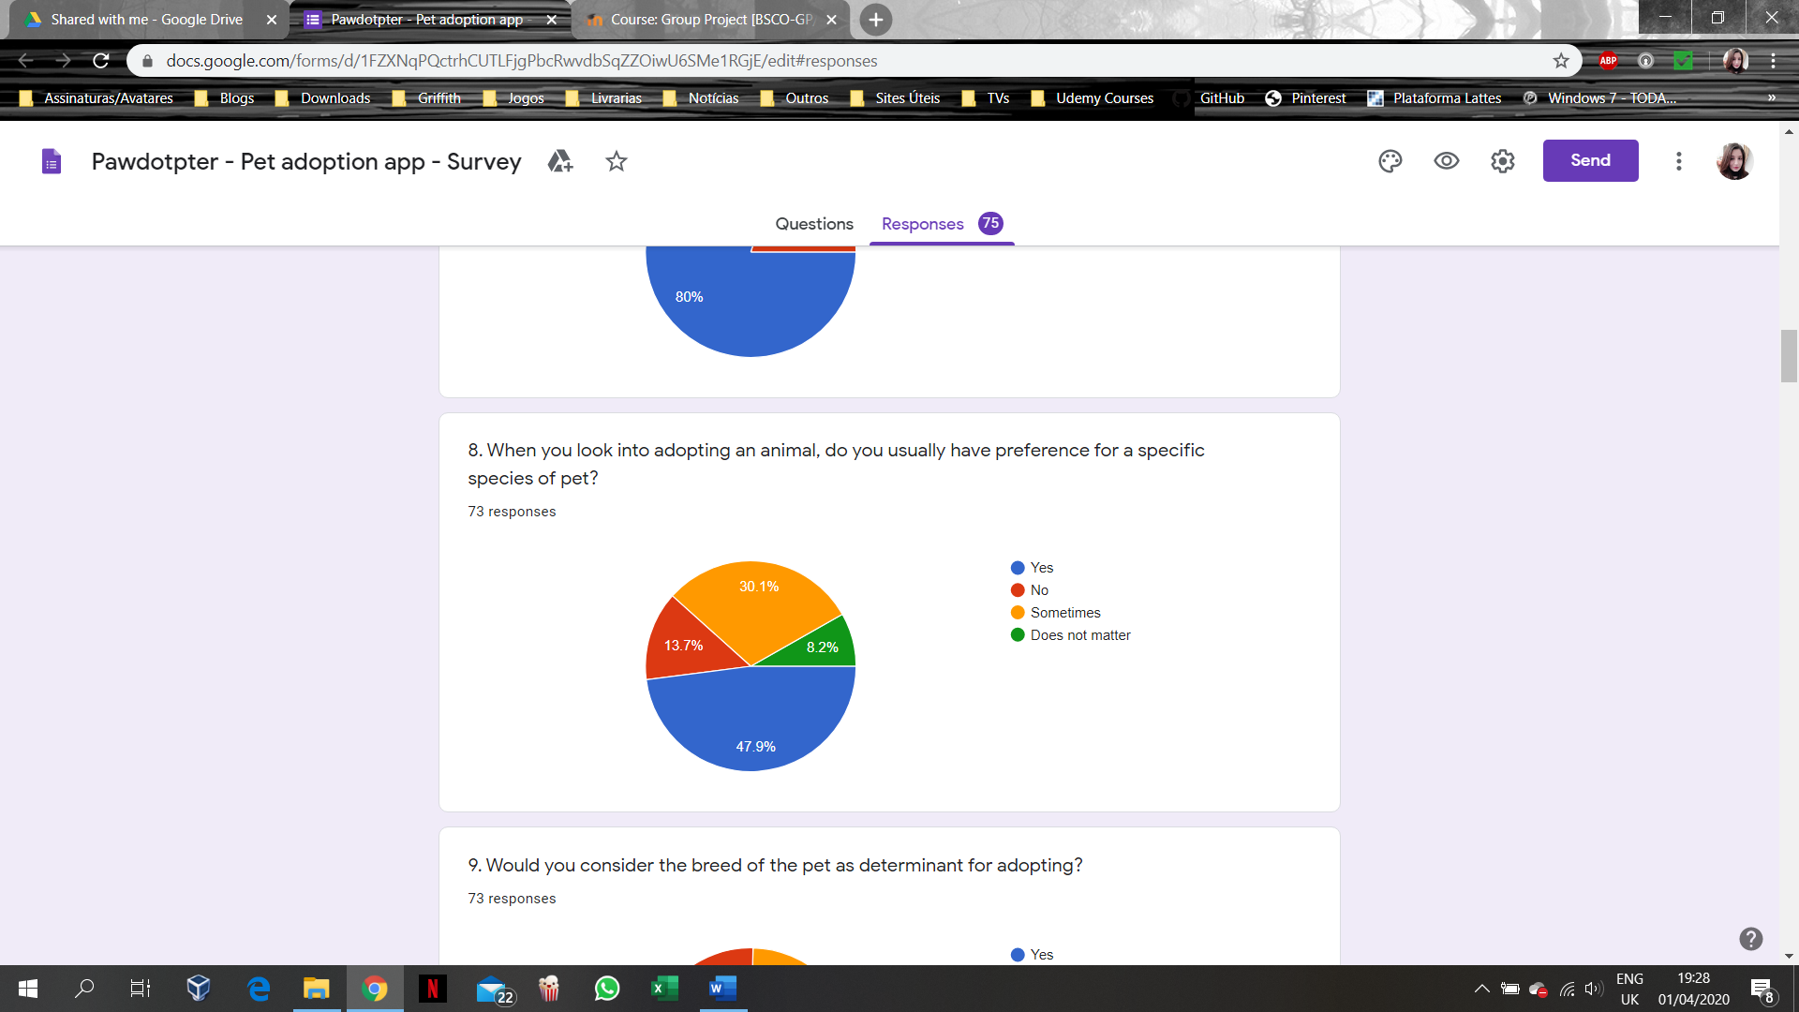

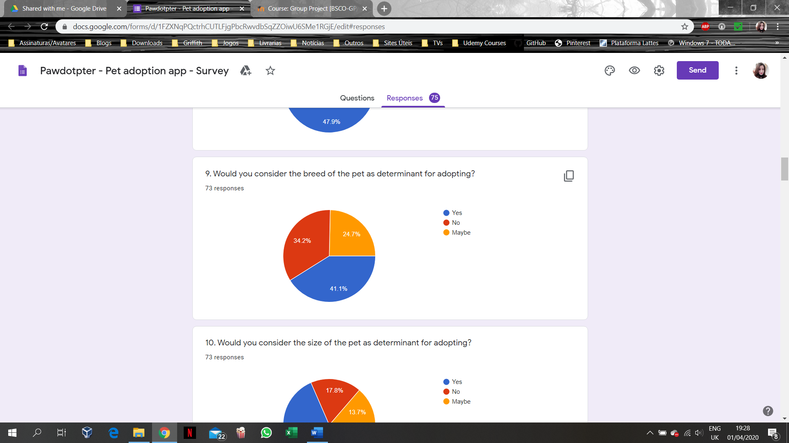

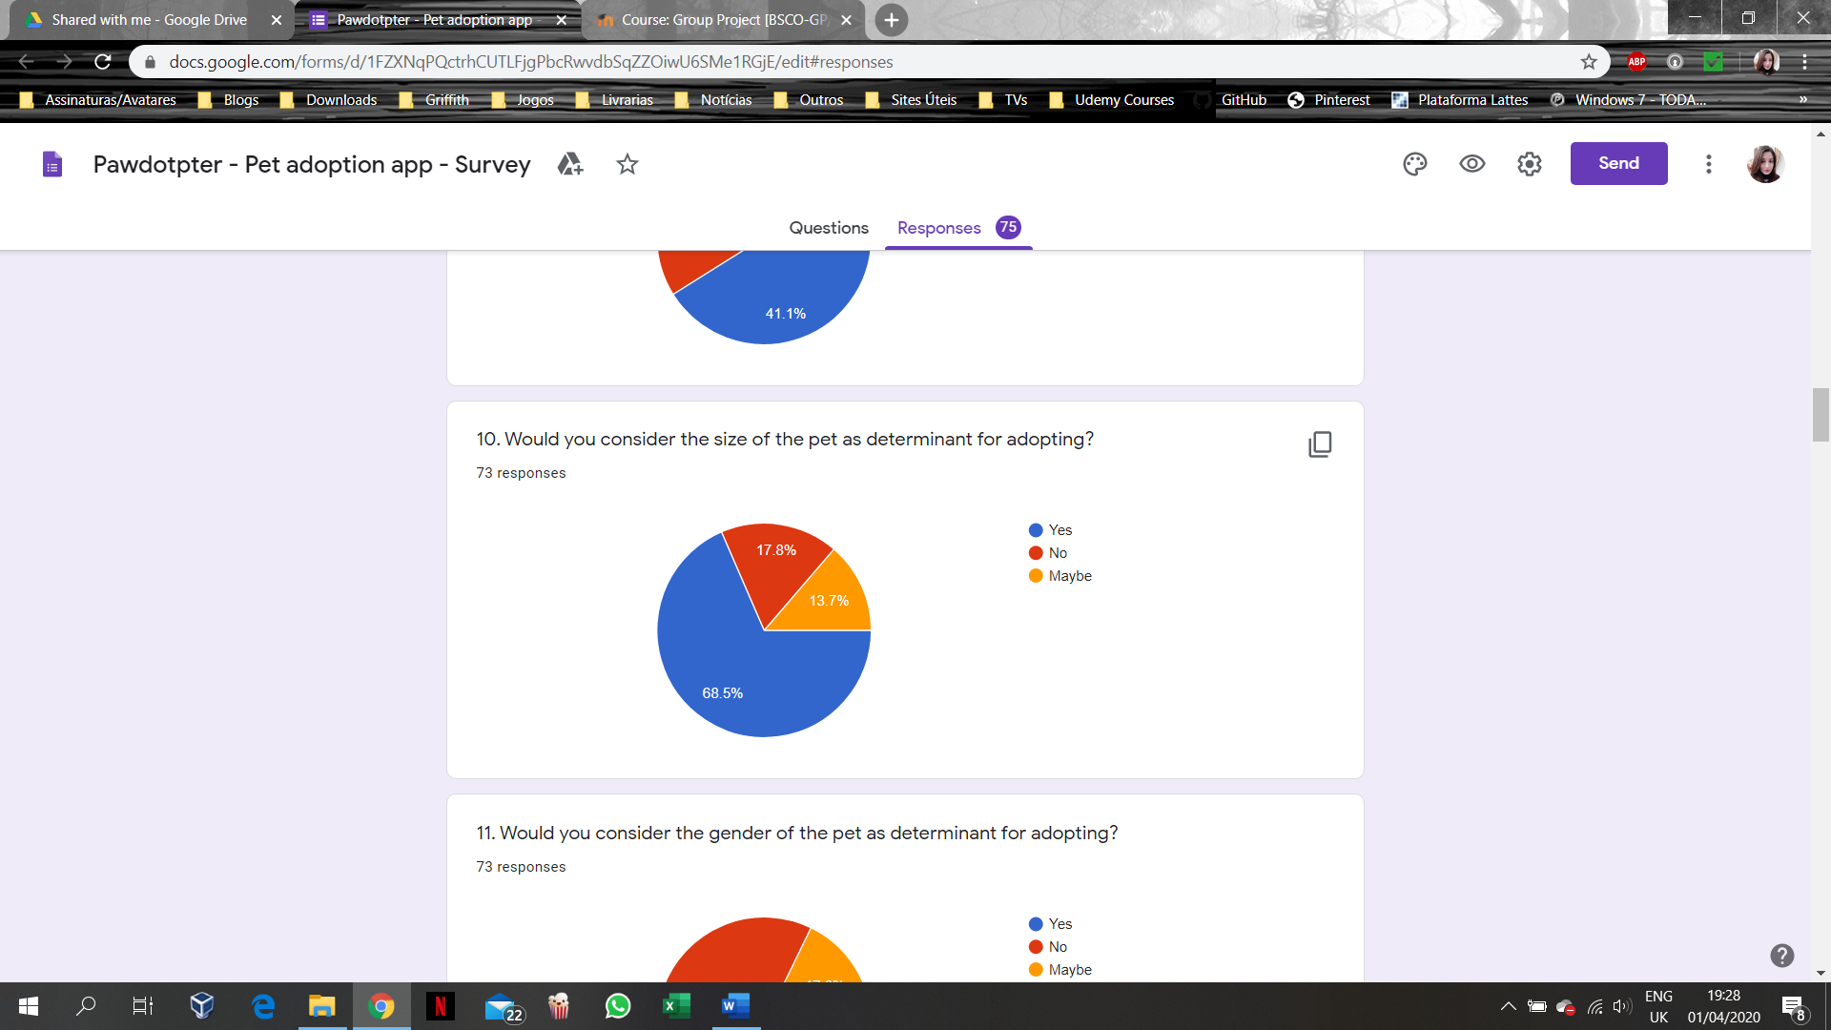

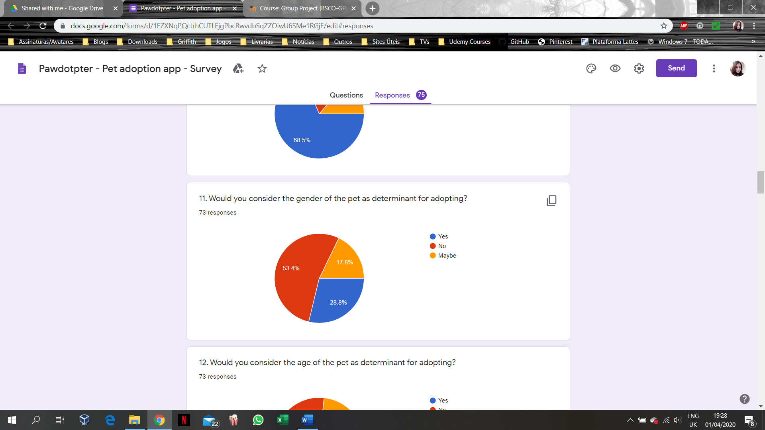

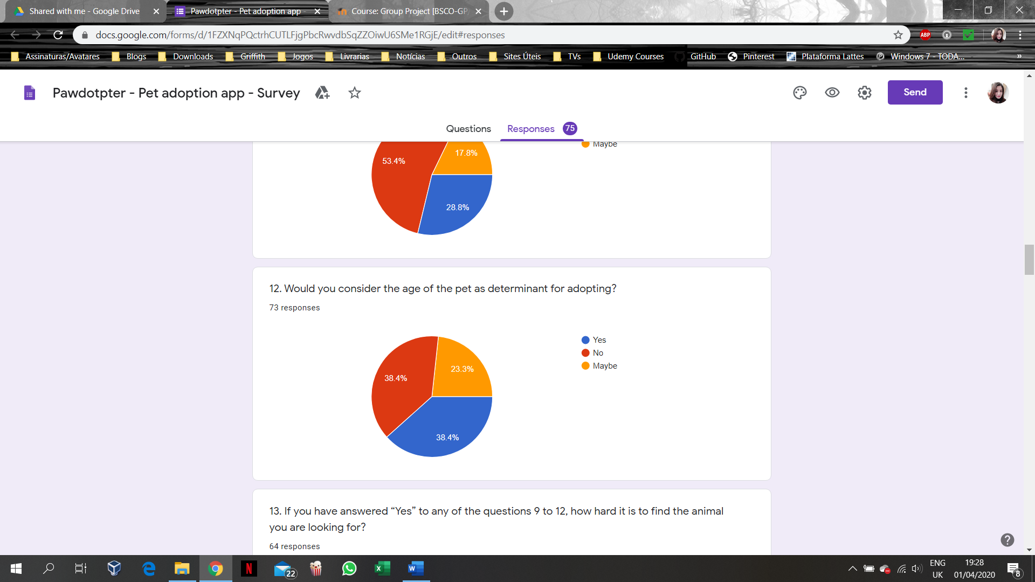

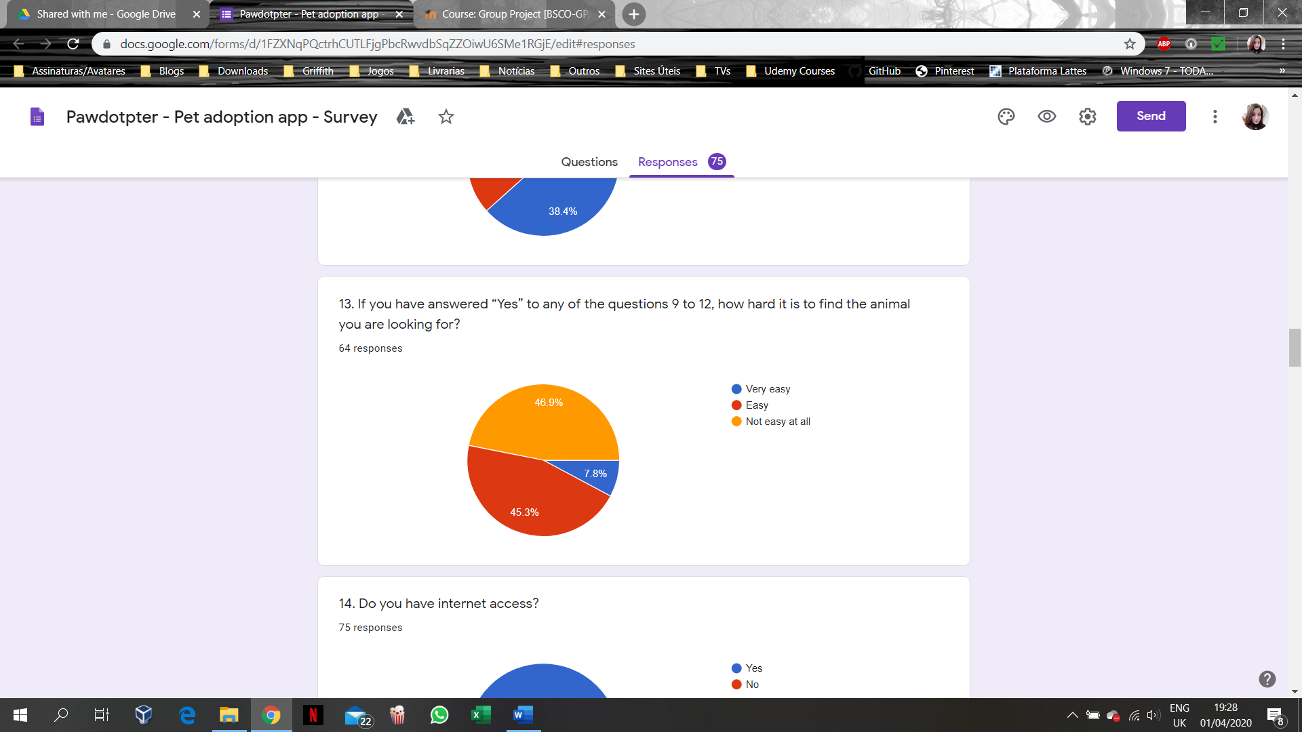

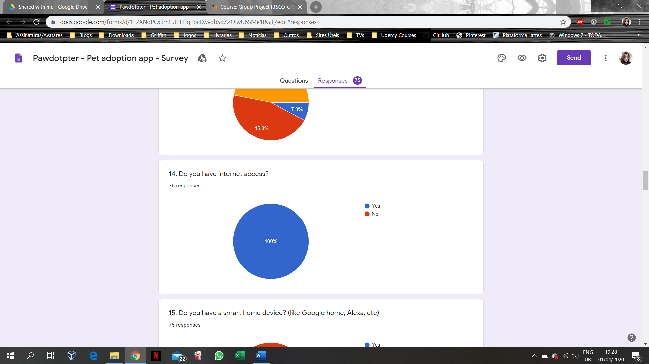

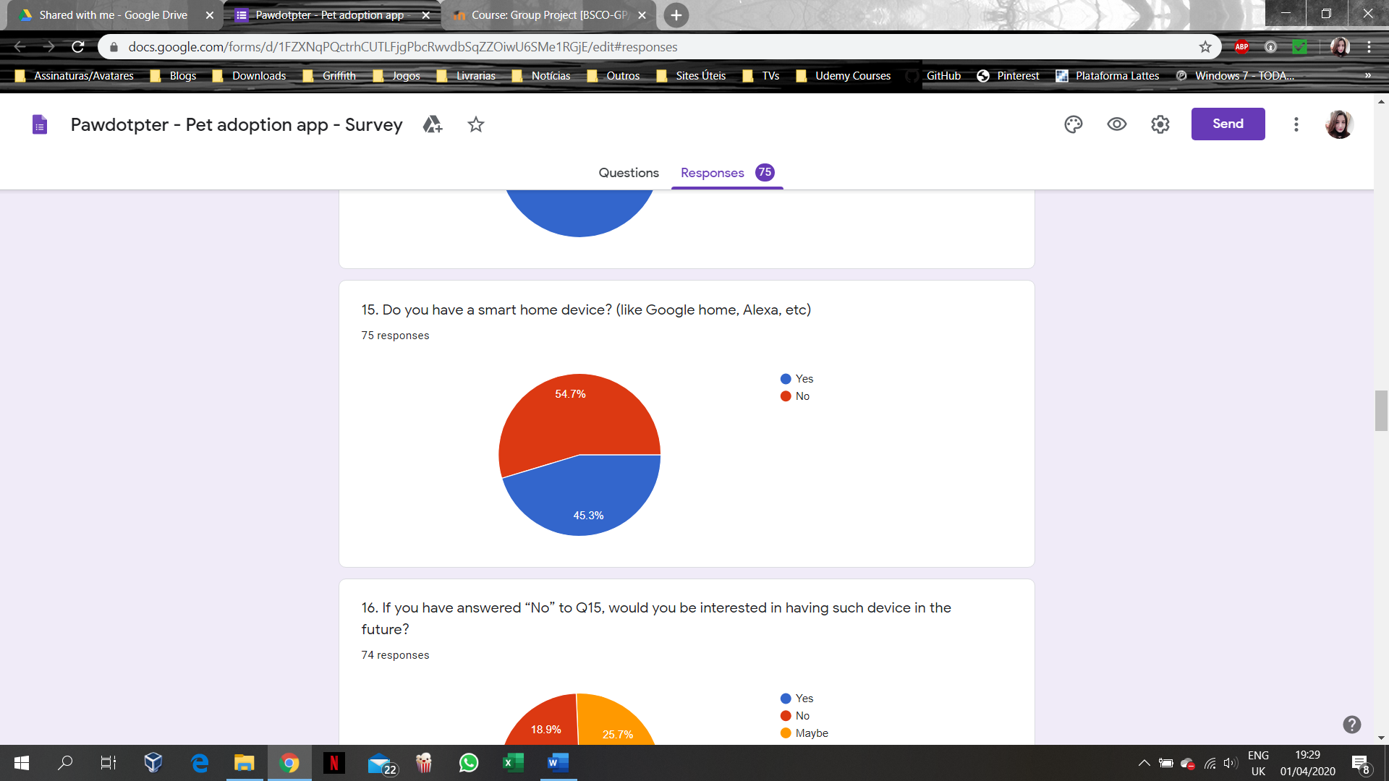

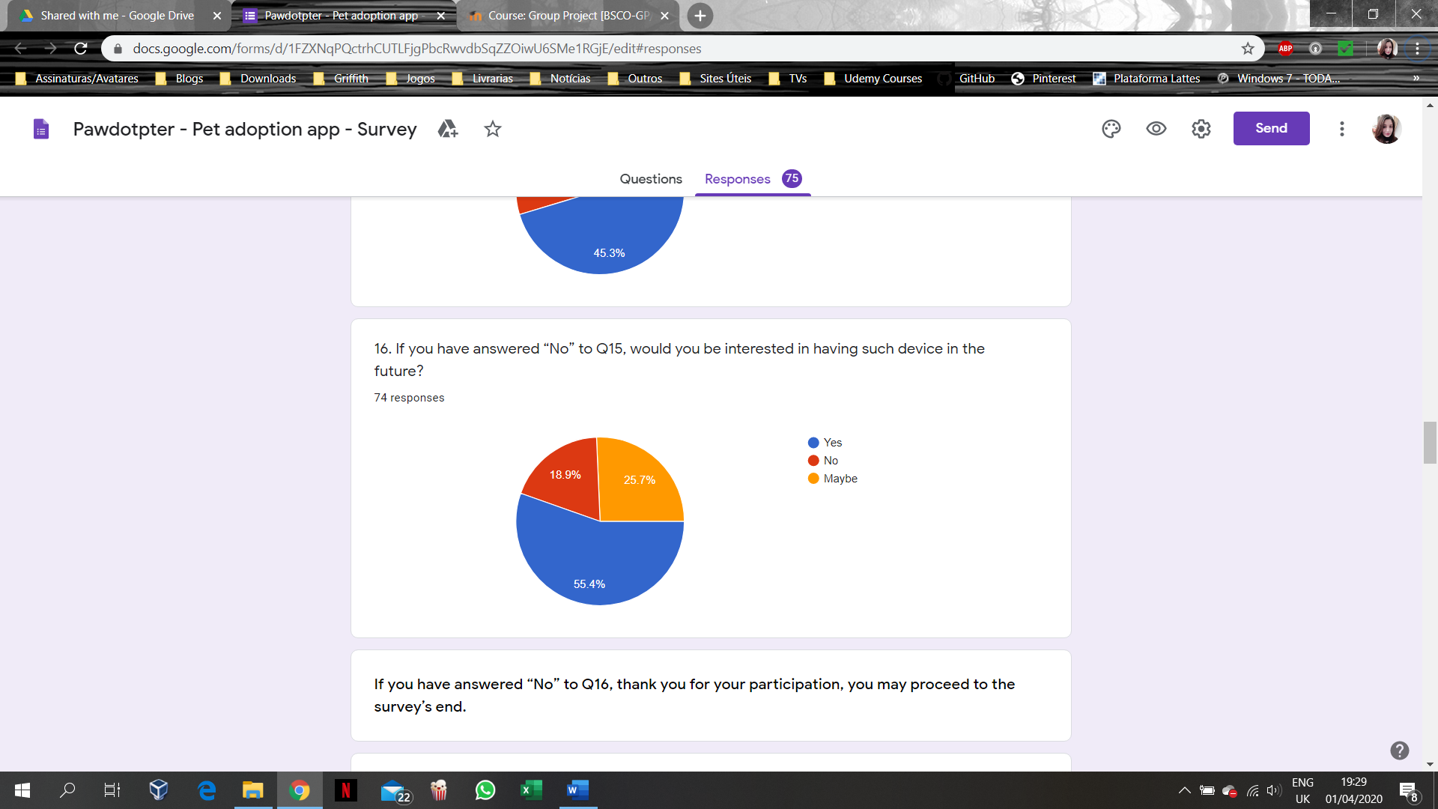

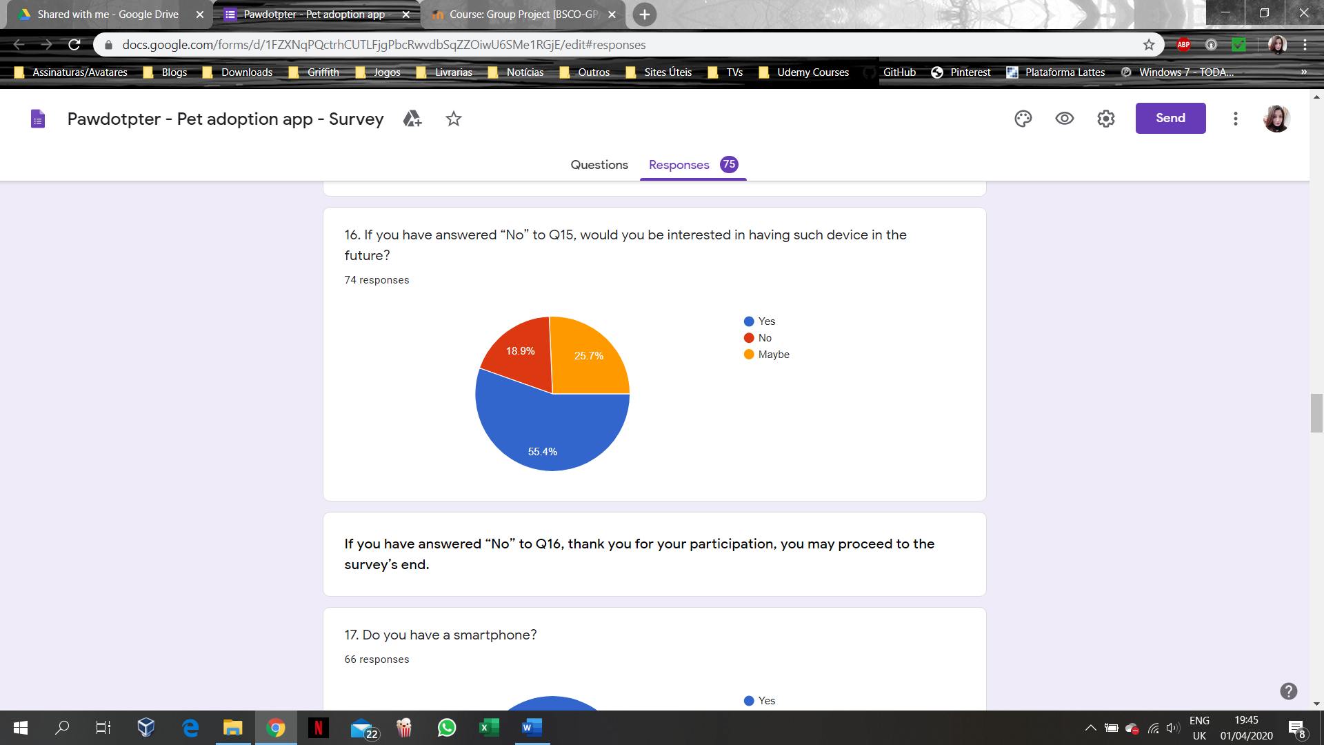

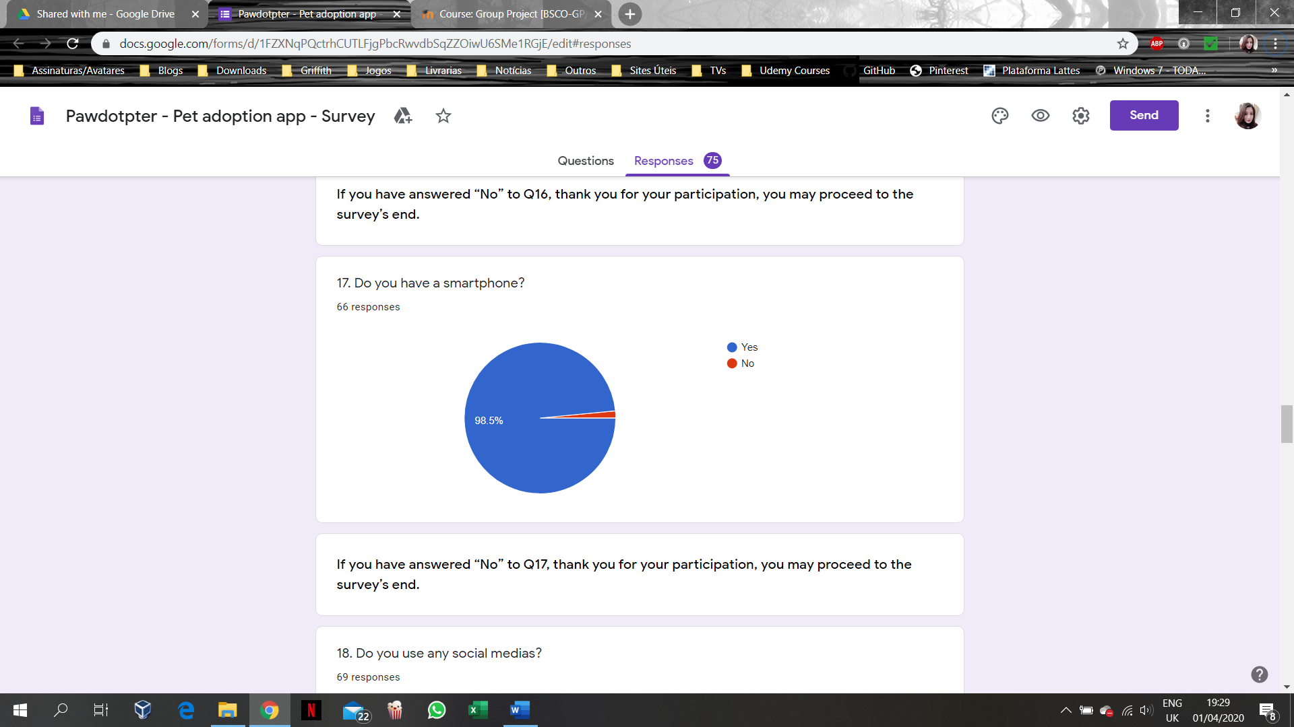

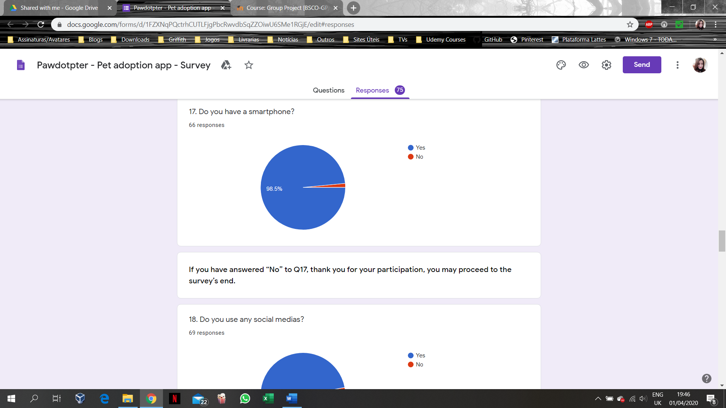

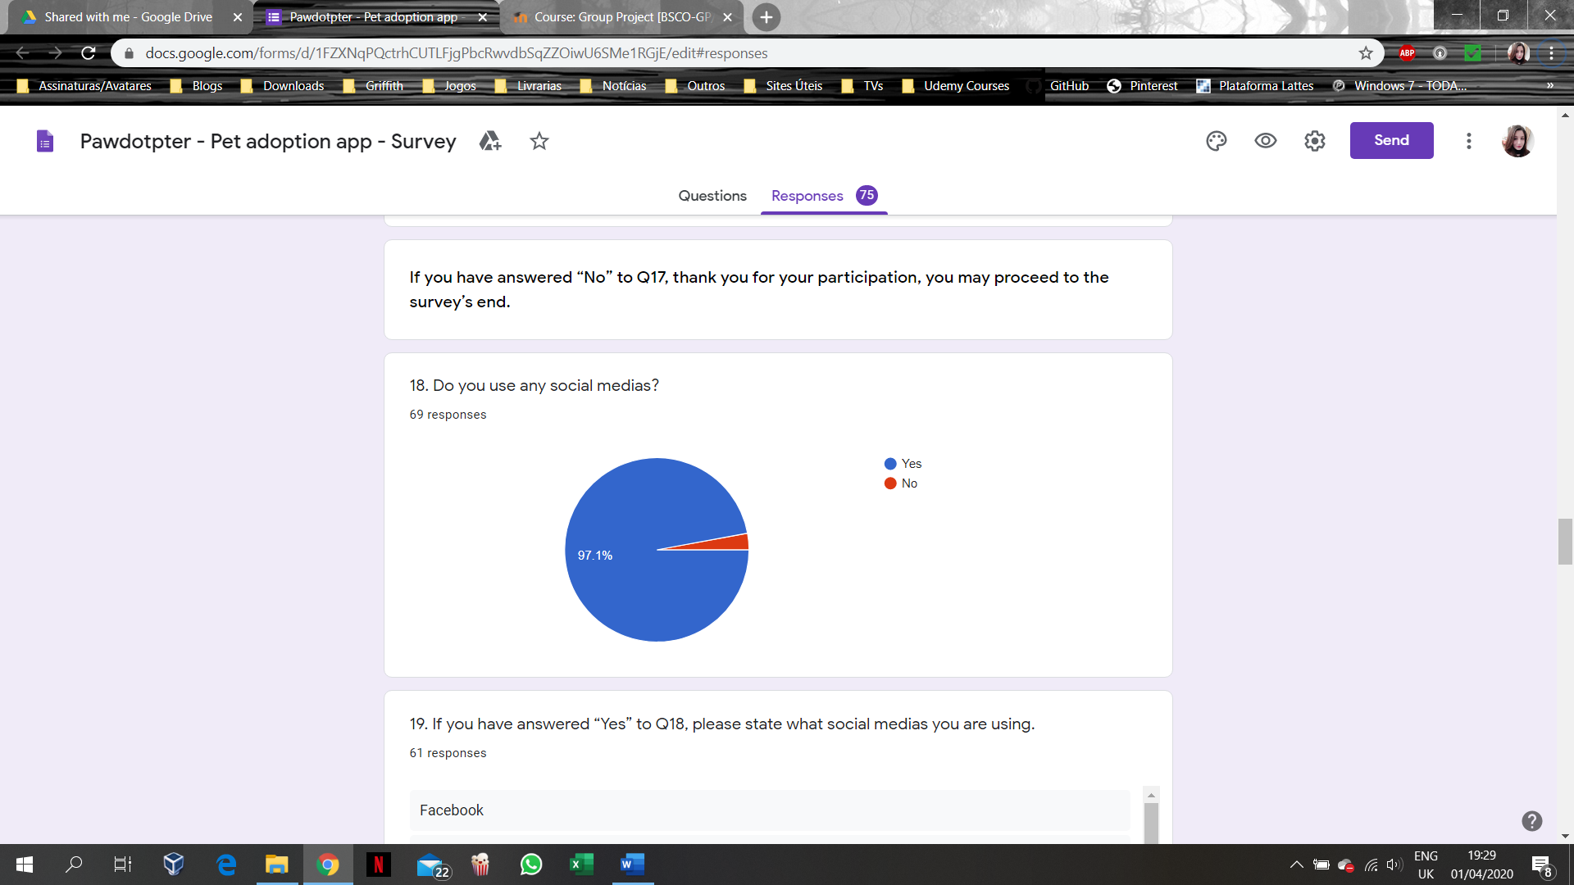

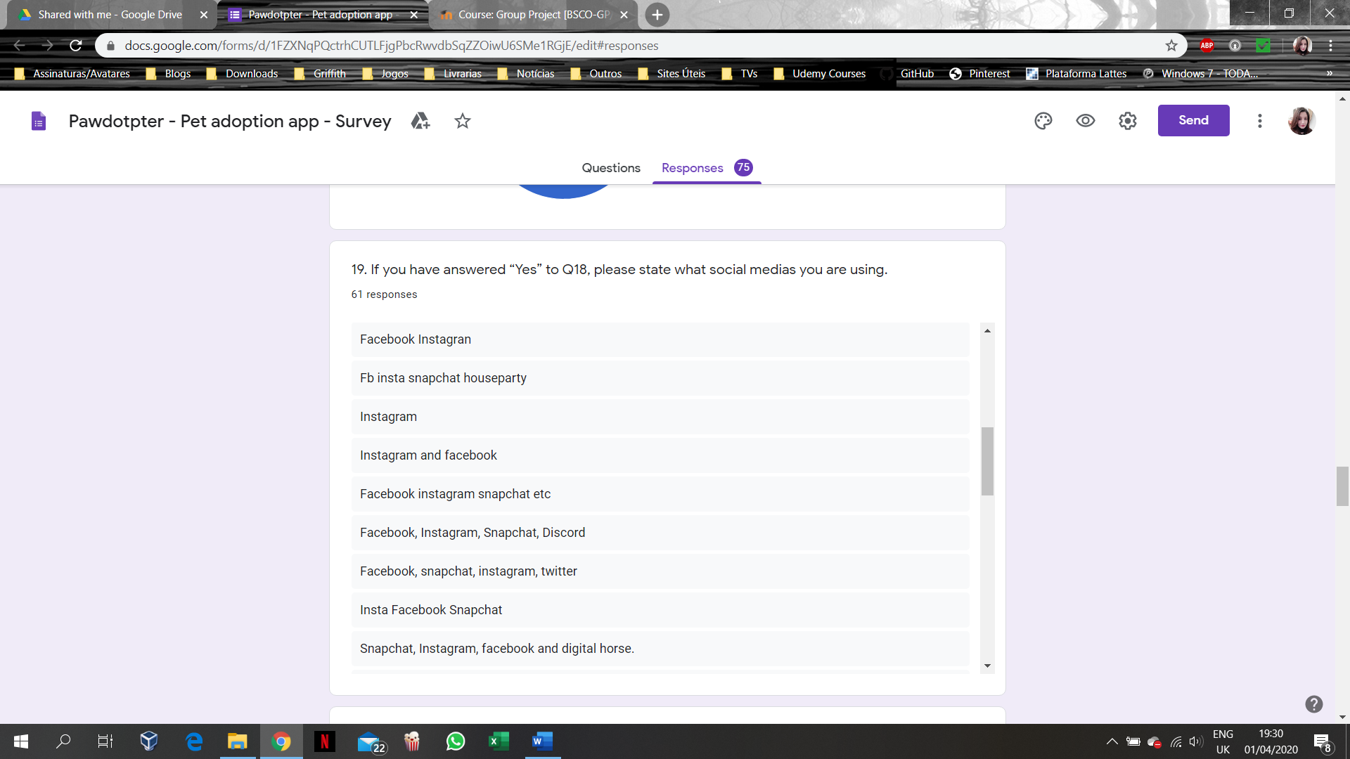

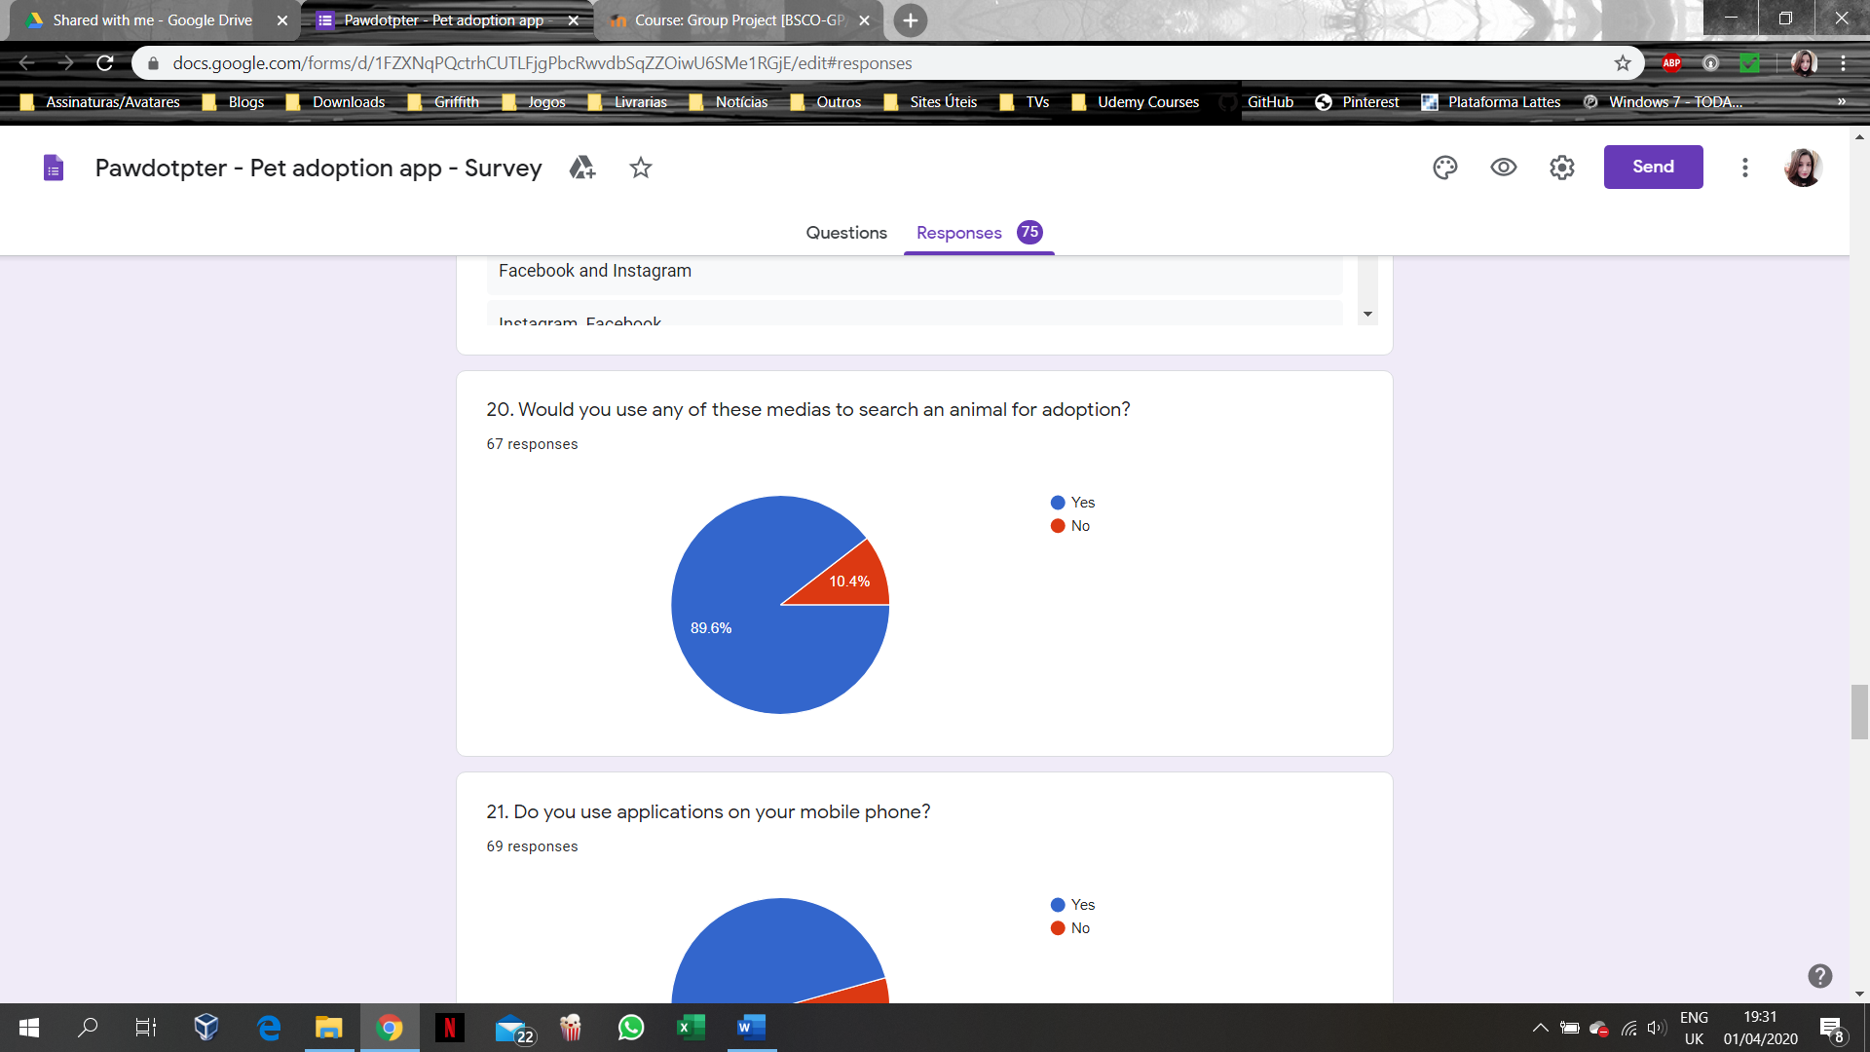

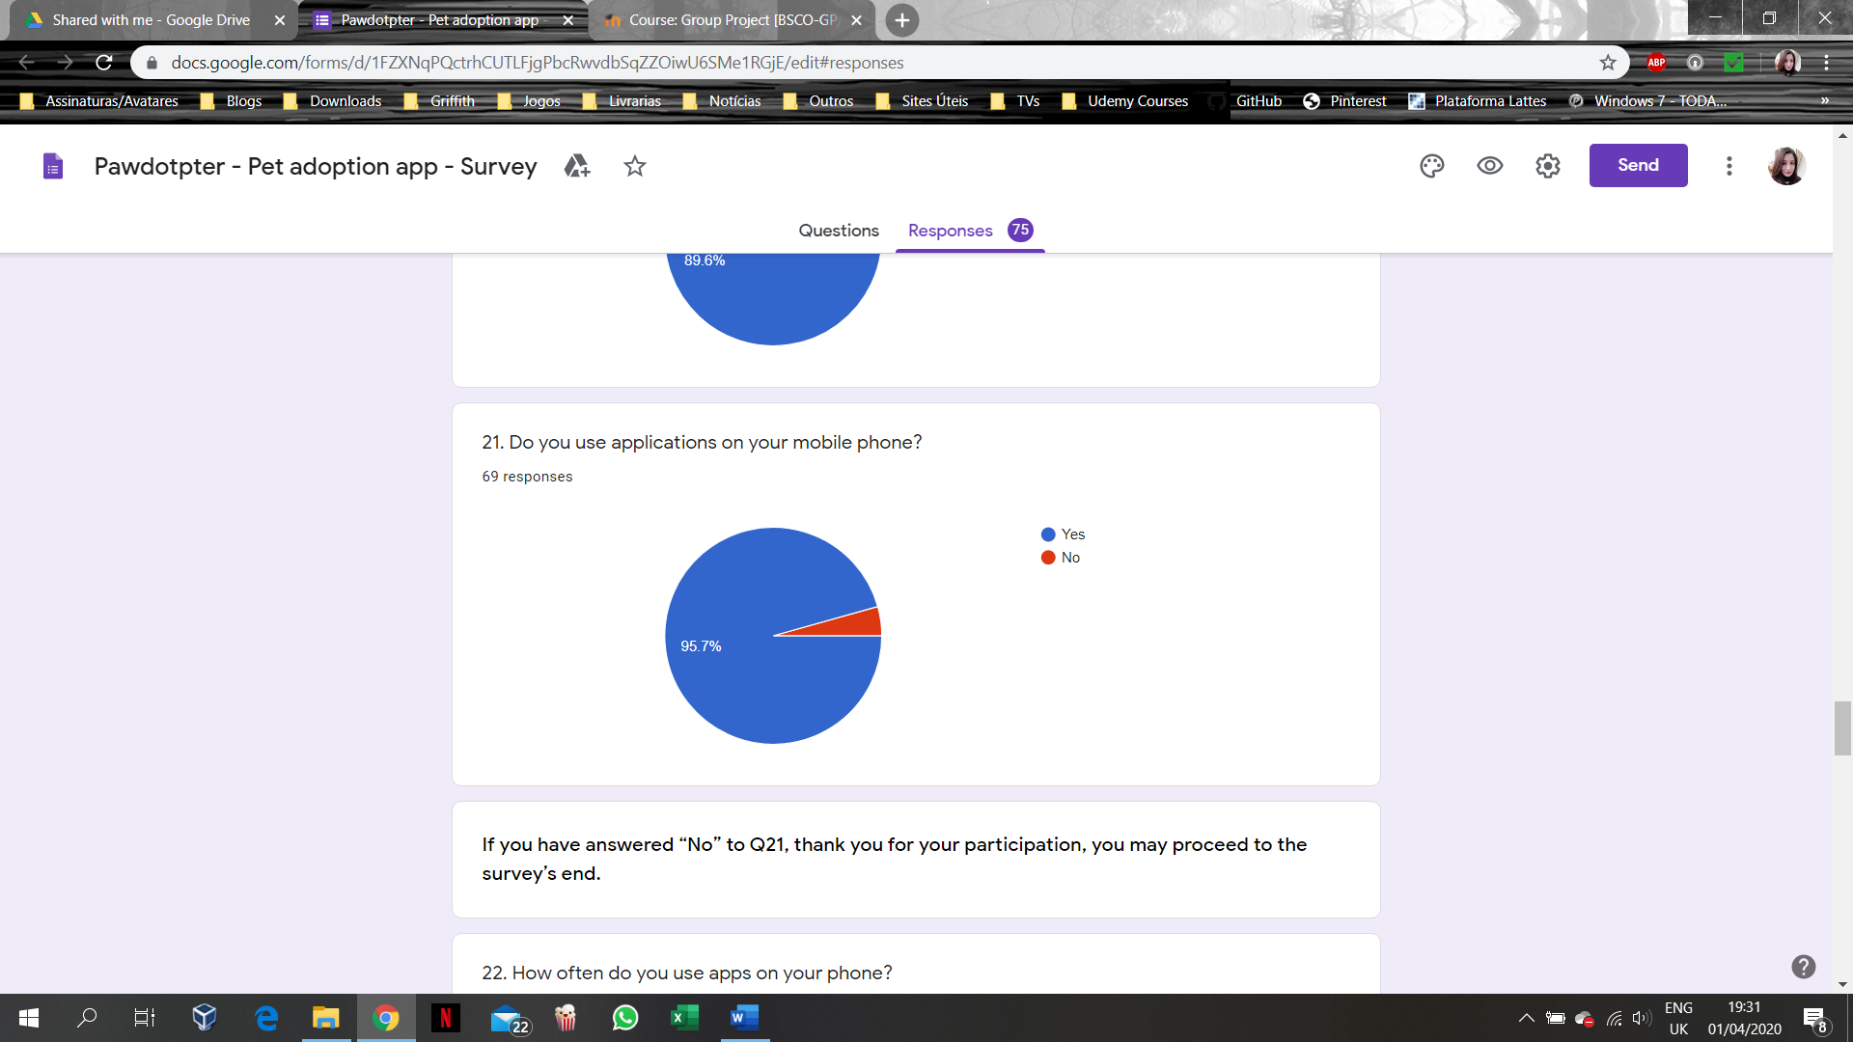

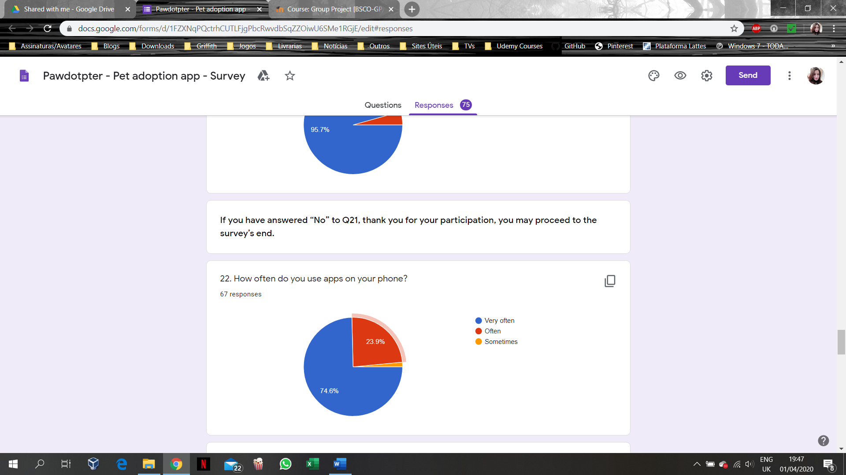

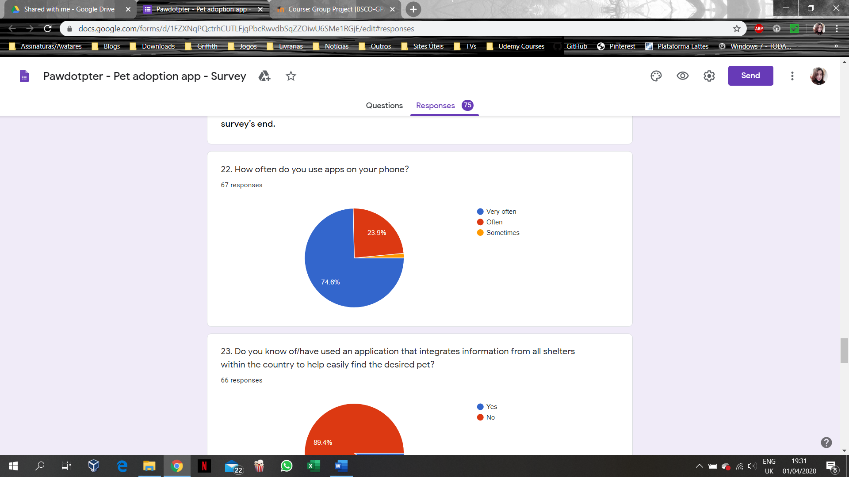

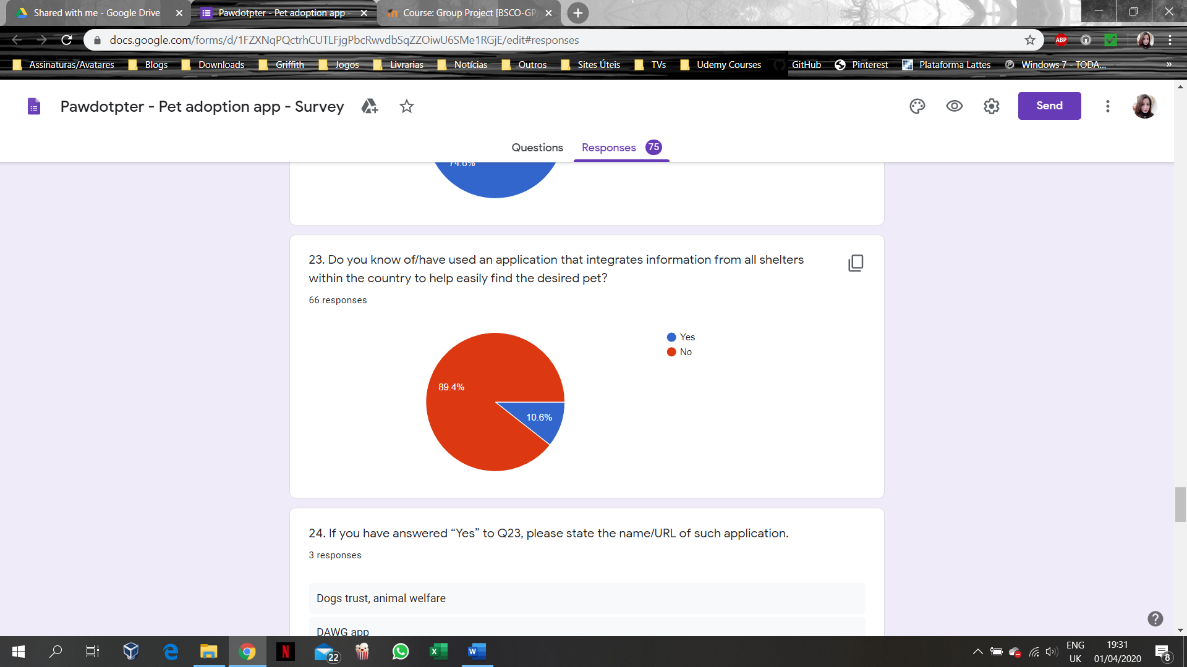

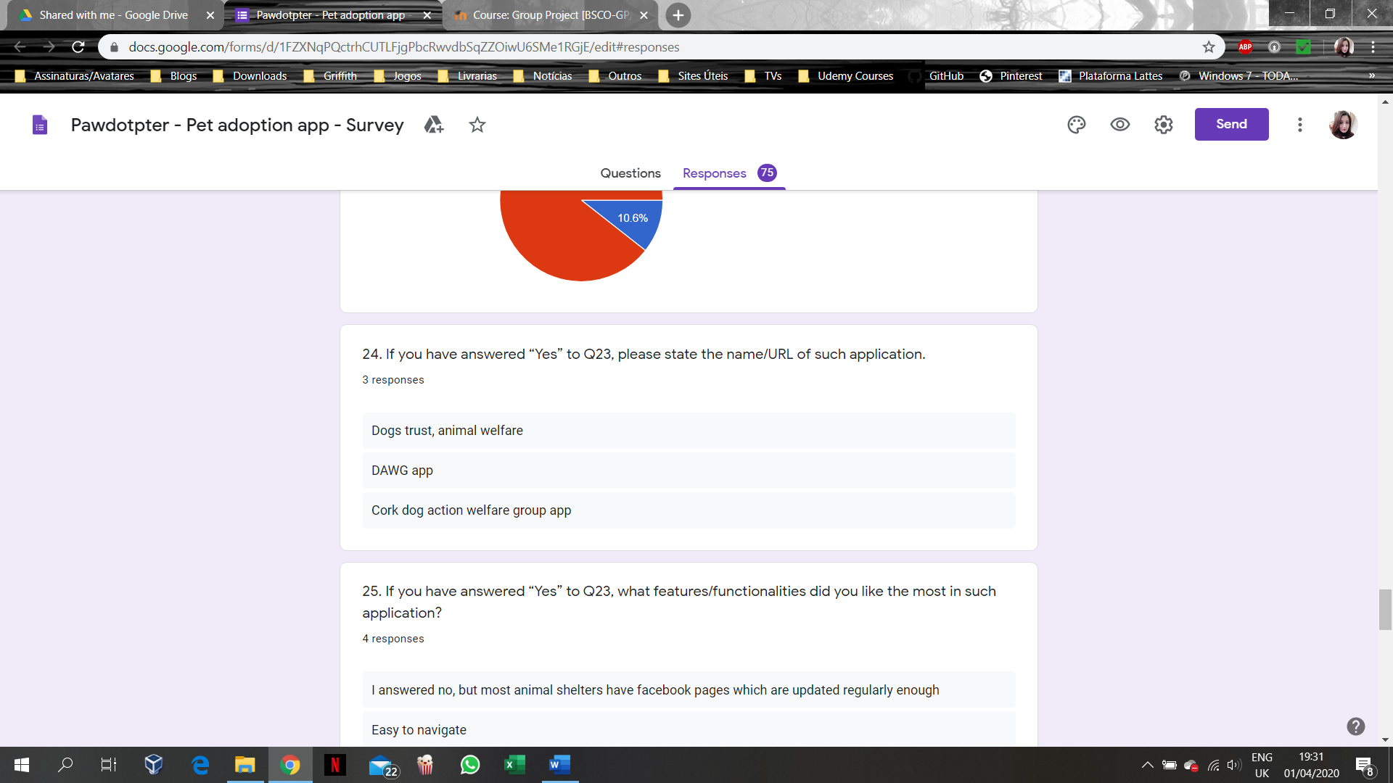

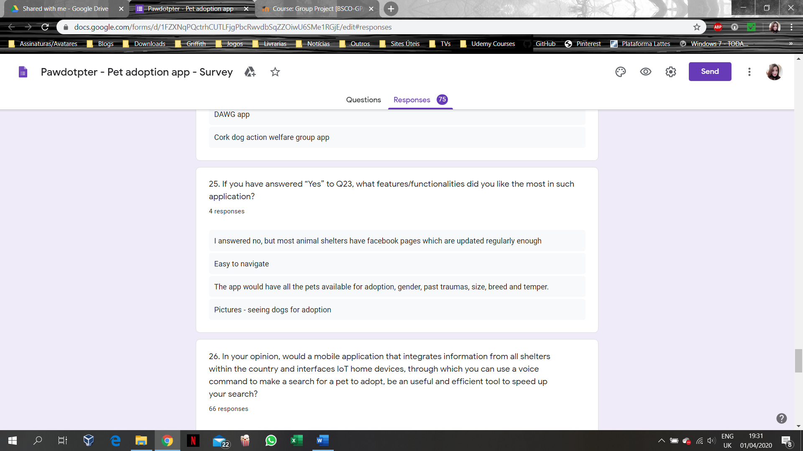

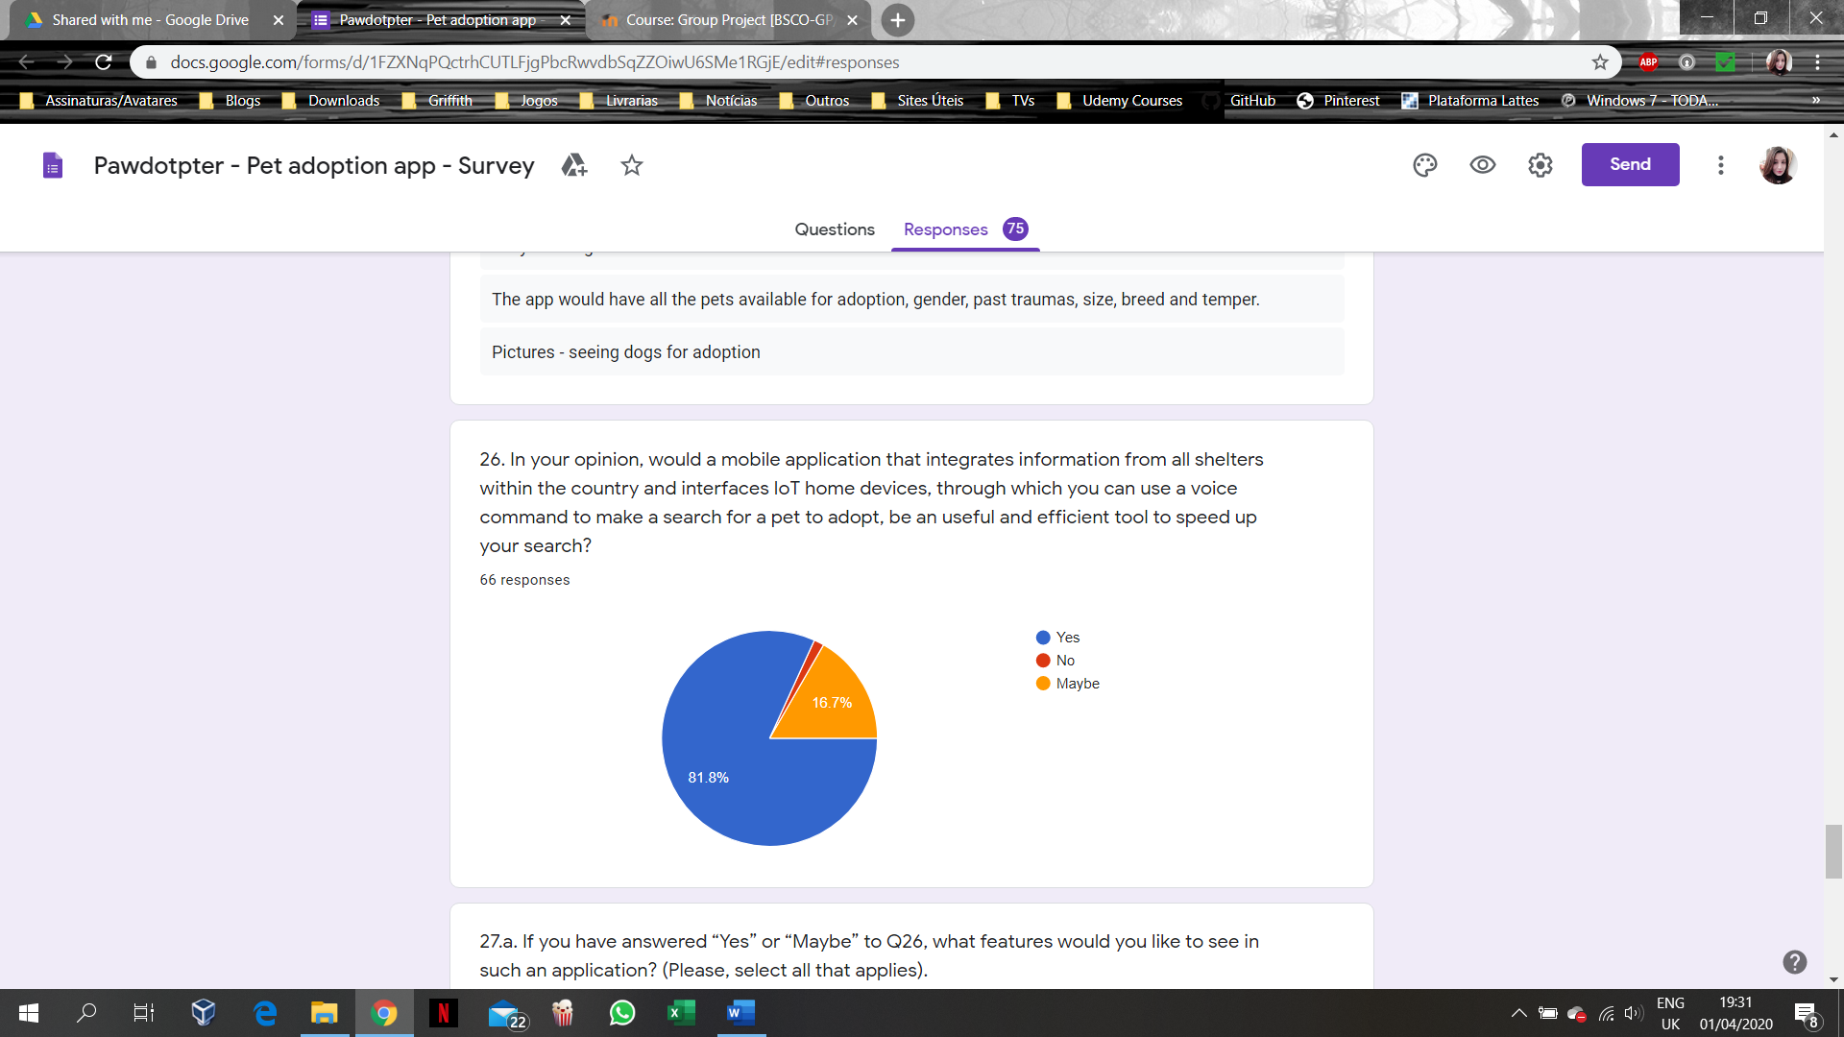

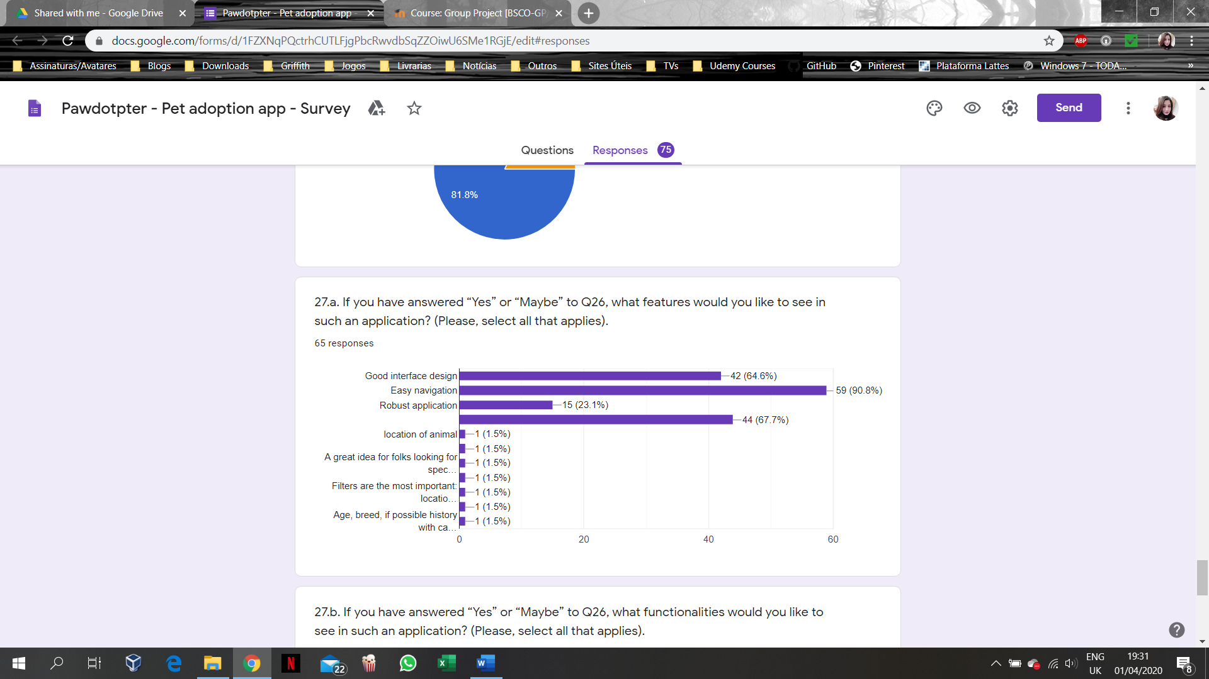

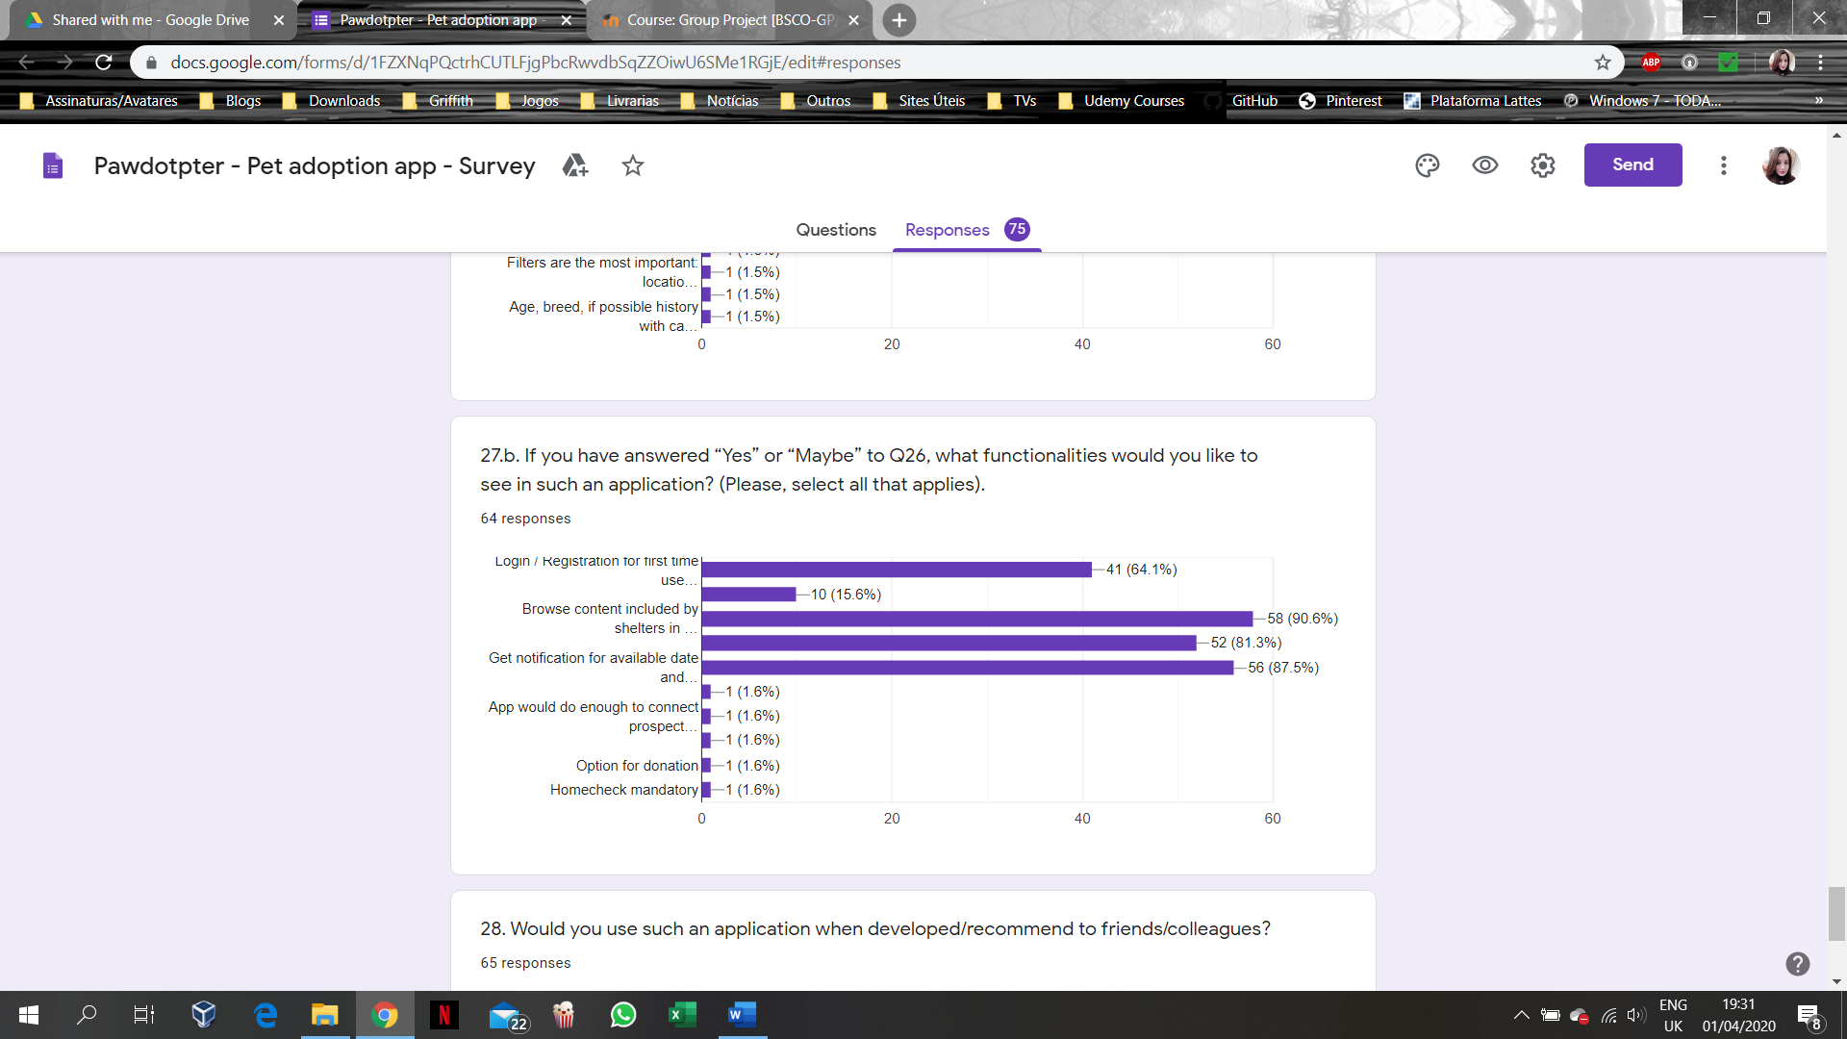

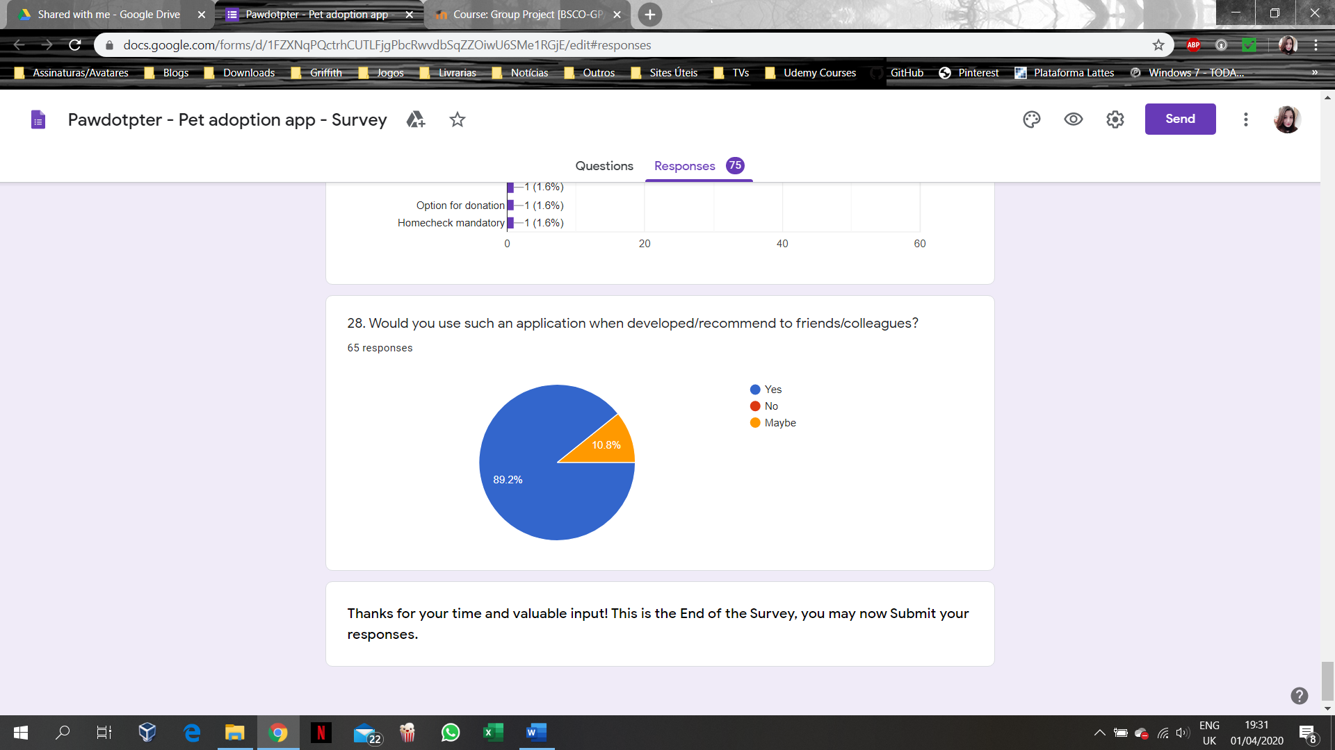

# APPENDIX A3: Structured Interview Questions for Shelter’s Management

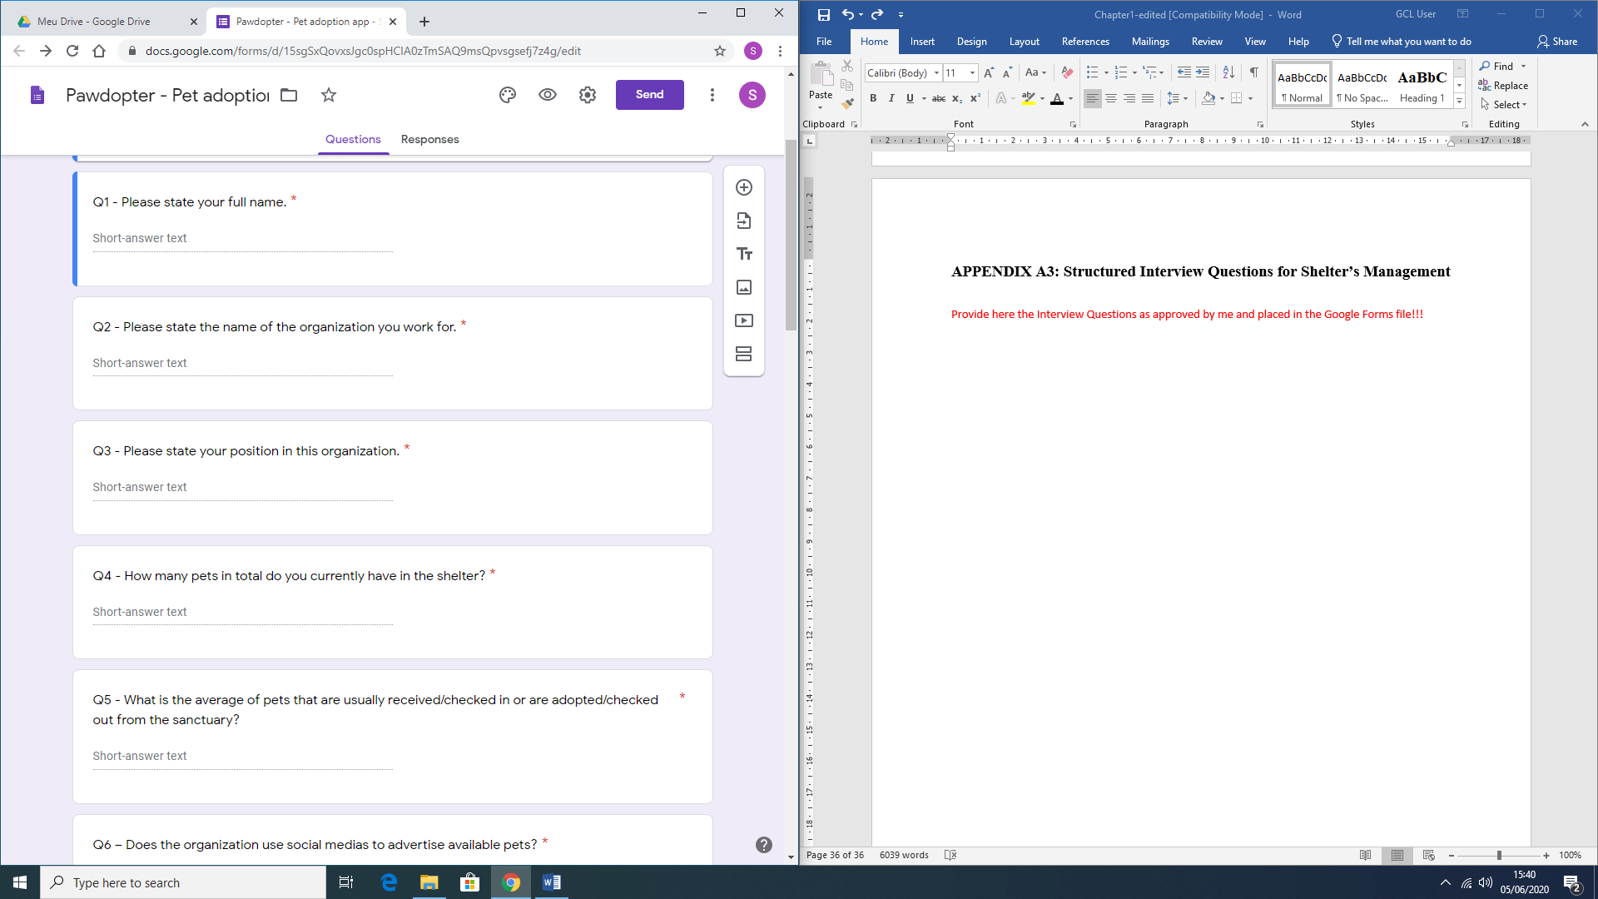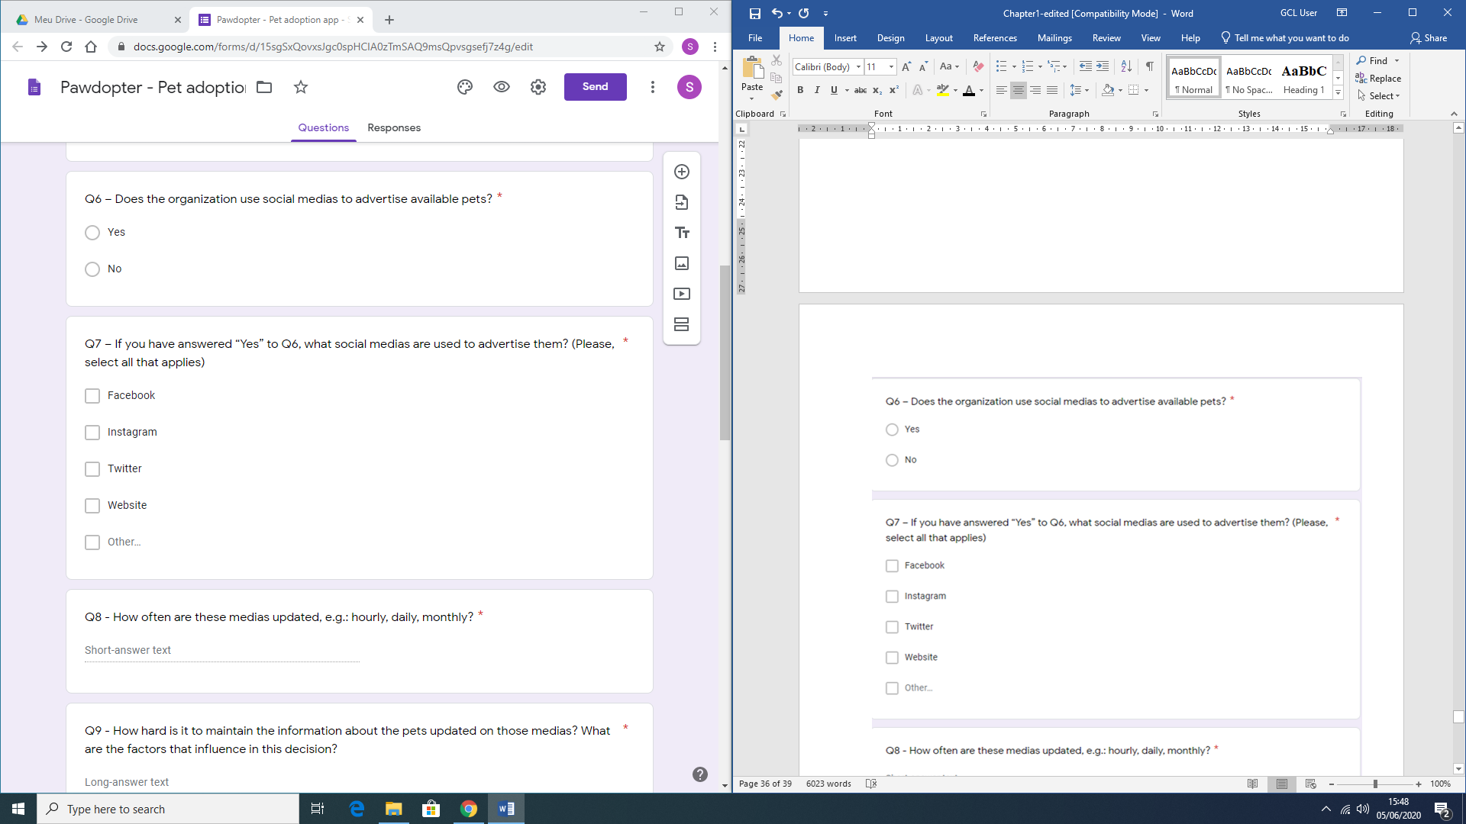

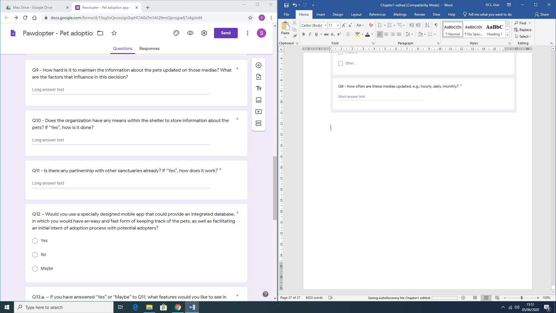

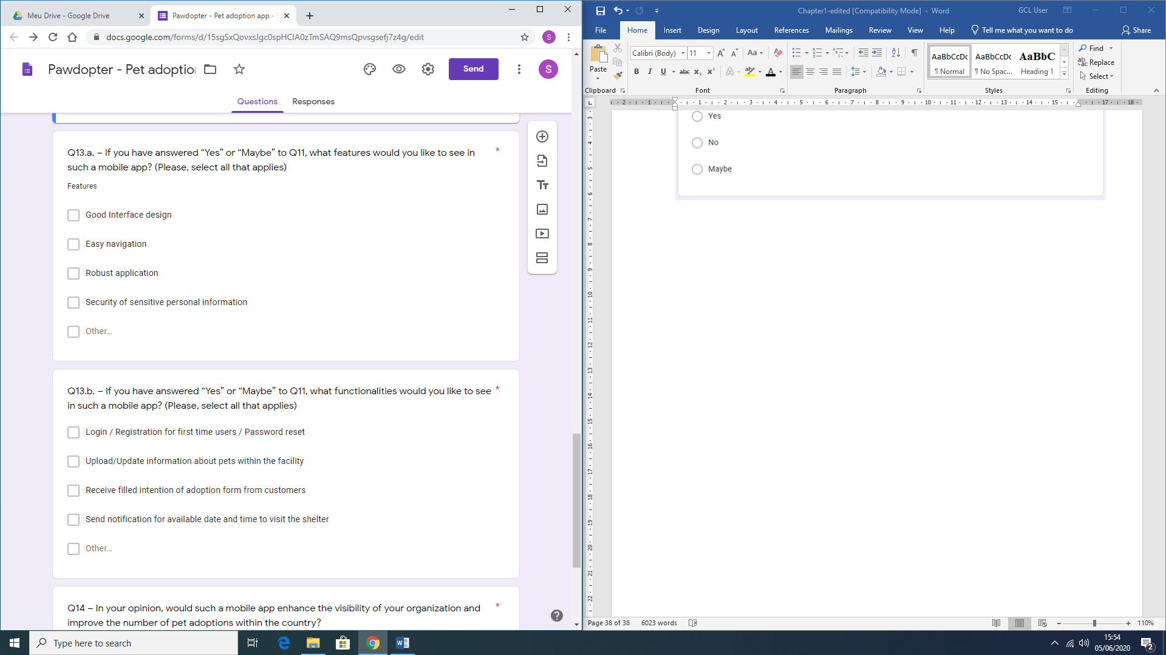

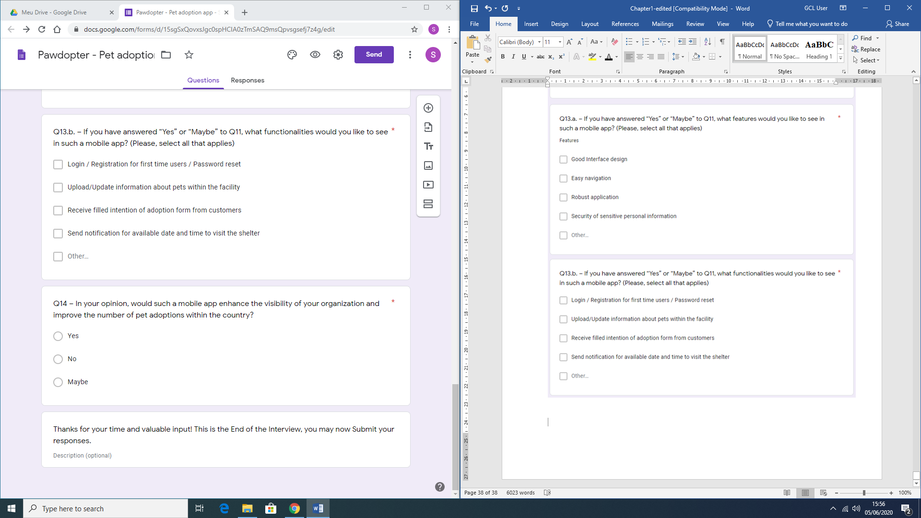

# APPENDIX A4: Animal shelters in Ireland by County

|  |  |
| --- | --- |
| **County** | **Shelter / Rescue / Pound name** |
|  |  |
| Clare |  |
|  | An Cat Dubh Sanctuary |
|  | Burren Animal Rescue |
|  | Clare Animal Welfare |
|  | Clare Dog Pound |
|  | Clare Greyhound Project |
|  | Clare Society for Prevention of Cruelty to Animals (Clare SPCA) |
|  | Homeward Bound |
|  | Martina's Babydog Rescue |
|  | Rover Rescue |
|  | The hogsprickle - Helping Hedgehogs |
|  |  |
| Cork |  |
|  | Animal Advocacy |
|  | Animal Care Society |
|  | Cork Cat Action Trust |
|  | Cork City Dog Pound |
|  | Cork County Dog Pound |
|  | Cork Society for Prevention of Cruelty to Animals (CSPCA) |
|  | Dog Action Welfare Group (DAWG) |
|  | Glansillagh Animal Rescue Centre |
|  | H.A.R.T |
|  | Pauline’s Rescue |
|  | RAWR (Rural Animal Welfare Resources) |
|  | The Donkey Sanctuary |
|  |  |
| Dublin |  |
|  | A Dog's Life |
|  | ARAN |
|  | Ashton Pound |
|  | Blue Cross Ireland |
|  | Cat and Dogs Protection Association of Ireland |
|  | Cats Aid |
|  | Cats Friends Rescue |
|  | Clondalkin Animal Aid |
|  | Dog Rescue Ireland (Greyhounds) |
|  | Dogs Aid |
|  | Dogs Angels Ireland |
|  | Dogs in Distress |
|  | Dogs Trust |
|  | Dublin Society for Prevention of Cruelty to Animals (DSPCA) |
|  | Dublin Small Animal Rescue |
|  | Glencarraig Dog Rescue |
|  | Last Chance Animals |
|  | My Lovely Horse Rescue |
|  | North Dublin Cat Rescue |
|  | North Dublin SPCA |
|  |  |
| Galway |  |
|  | Galway Cat Rescue |
|  | Galway County Dog Pound |
|  | Galway Society for Prevention of Cruelty to Animals (Galway SPCA) |
|  | Irish Pound Dogs |
|  | MADRA - Mutts Anonymous Dog Rescue and Adoption |
|  | Renvyle Cat and Dog Rescue |
|  | Whiskers New Park Animal Sanctuary |
|  |  |
| Kerry |  |
|  | Animal Help Net |
|  | HUG Homes for unwanted Greyhounds |
|  | Kerry Dog Pound |
|  | Kerry Society for Prevention of Cruelty to Animals (Kerry SPCA) |
|  | Kingdom Cat and Dog Rescue (KCADR) |
|  | KLAWS |
|  |  |
| Kildare |  |
|  | Celtic Animal Life Line |
|  | Kildare and West Wicklow Society for Prevention of Cruelty to Animals (KWWSPCA) |
|  | Kildare Animal Foundation |
|  | Kildare Dog Pound |
|  | The Rat Retreat Ireland |
|  |  |
| Kilkenny |  |
|  | Carlow Kilkenny Dog Pound |
|  | Inistioge Puppy Rescue |
|  | Kilkenny Society for Prevention of Cruelty to Animals (Kilkenny SPCA) |
|  |  |
| Laois |  |
|  | Cara Dog Rescue |
|  | Laois Dog Pound |
|  | Laois Society for Prevention of Cruelty to Animals (Laois SPCA) |
|  |  |
| Leitrim |  |
|  | Leitrim Animal Welfare |
|  | Leitrim Dog Pound |
|  | Leitrim Society for Prevention of Cruelty to Animals (Leitrim SPCA) |
|  |  |
| Limerick |  |
|  | Limerick Animal Welfare |
|  | Limerick City and County Dog Shelter |
|  | Limerick Society for Prevention of Cruelty to Animals (Limerick SPCA) |
|  |  |
| Longford |  |
|  | Hungry Horse Outside |
|  | Irish Society for Prevention of Cruelty to Animals (ISPCA) |
|  | Longford Dog Pound |
|  | Longford Society for Prevention of Cruelty to Animals (Longford SPCA) |
|  |  |
| Louth |  |
|  | Collon Animal Sanctuary |
|  | Drogheda Animal Rescue |
|  | Dundalk Dog Rescue |
|  | Louth Dog Pound |
|  | Louth Society for Prevention of Cruelty to Animals (Louth SPCA) |
|  | Westie Rescue |
|  |  |
| Mayo |  |
|  | Ainmhithe Animal Rescue |
|  | Horse and Donkey Mayo Sanctuary |
|  | Mayo Dog Pound |
|  | Mayo Society for Prevention of Cruelty to Animals (Mayo SPCA) |
|  | North West Society for Prevention of Cruelty to Animals (NWSPCA) |
|  |  |
| Meath |  |
|  | Dog Rescue Coolronan |
|  | Eden Farmed Animal Sanctuary |
|  | Last Hope Animals |
|  | Meath Dog Pound |
|  | National Exotic Animal Sanctuary |
|  | Royal Dog Rescue |
|  |  |
| Offaly |  |
|  | Offaly Dog Pound |
|  | Offaly Society for Prevention of Cruelty to Animals (OSPCA) |
|  | Orchard Greyhound Sanctuary Ireland |
|  |  |
| Roscommon |  |
|  | Athlone & West Midlands Society for Prevention of Cruelty to Animals (Athlone & West Midlands SPCA) |
|  | Glen Of Imaal Terrier Rescue Ireland |
|  | Heart of Ireland Animal Rescue & Rehabilitation |
|  | Roscommon Dog Pound |
|  | Roscommon Society for Prevention of Cruelty to Animals (Roscommon SPCA) |
|  |  |
| Sligo |  |
|  | Sathya Sai Sanctuary Trust for Nature |
|  | Sligo Dog Shelter |
|  |  |
| Tipperary |  |
|  | Cottage Rescue |
|  | Mo Chara Animal Rescue |
|  | PAWS |
|  | Tipperary Dog Pound |
|  |  |
| Waterford |  |
|  | Deise Animal Sanctuary |
|  | Rosóg Equine Rescue |
|  | Waterford Dog Shelter |
|  |  |
| Westmeath |  |
|  | Moate & Midlands Dog Rescue |
|  | Shirley's Abandoned Cat and Dog Rescue |
|  | Westmeath Dog Pound |
|  |  |
| Wexford |  |
|  | Halfway Hen House |
|  | Irish Wildlife Sanctuary |
|  | Network Dog Rescue |
|  | New Ross Society for Prevention of Cruelty to Animals (New Ross SPCA) |
|  | North Wexford Society for Prevention of Cruelty to Animals (North Wexford SPCA) |
|  | Seal Rescue Ireland |
|  | South East Animal Rescue |
|  | Wexford Dog Pound |
|  | Wexford Society for Prevention of Cruelty to Animals (Wexford SPCA) |
|  |  |
| Wicklow |  |
|  | Ash Animal Rescue |
|  | Aughrim Cat Rescue |
|  | Greystones Kitty Hostel Rescue & TNR |
|  | IHWT Equine Welfare Centre |
|  | Wicklow Animal Welfare |
|  | Wicklow Dog Pound |
|  | Wicklow Society for Prevention of Cruelty to Animals (Wicklow SPCA) |

# APPENDIX A5: Use Case Diagram

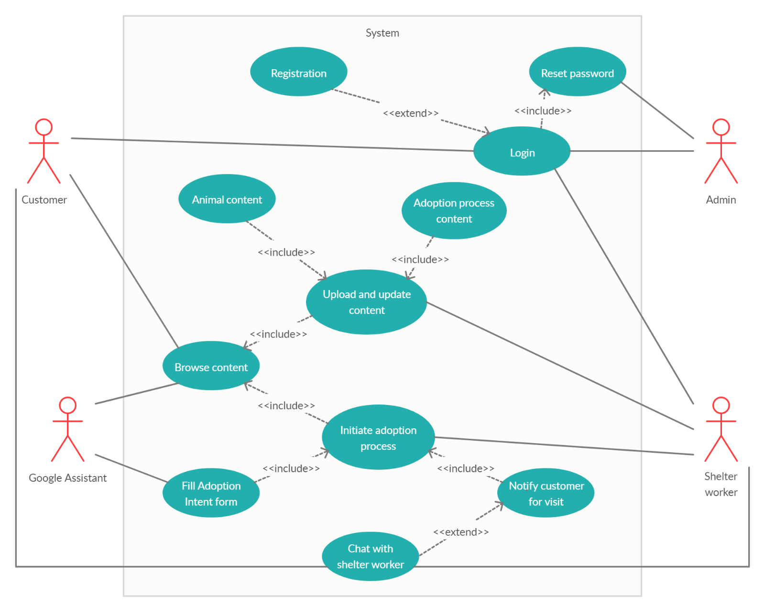

# APPENDIX A6: Sequence Diagram

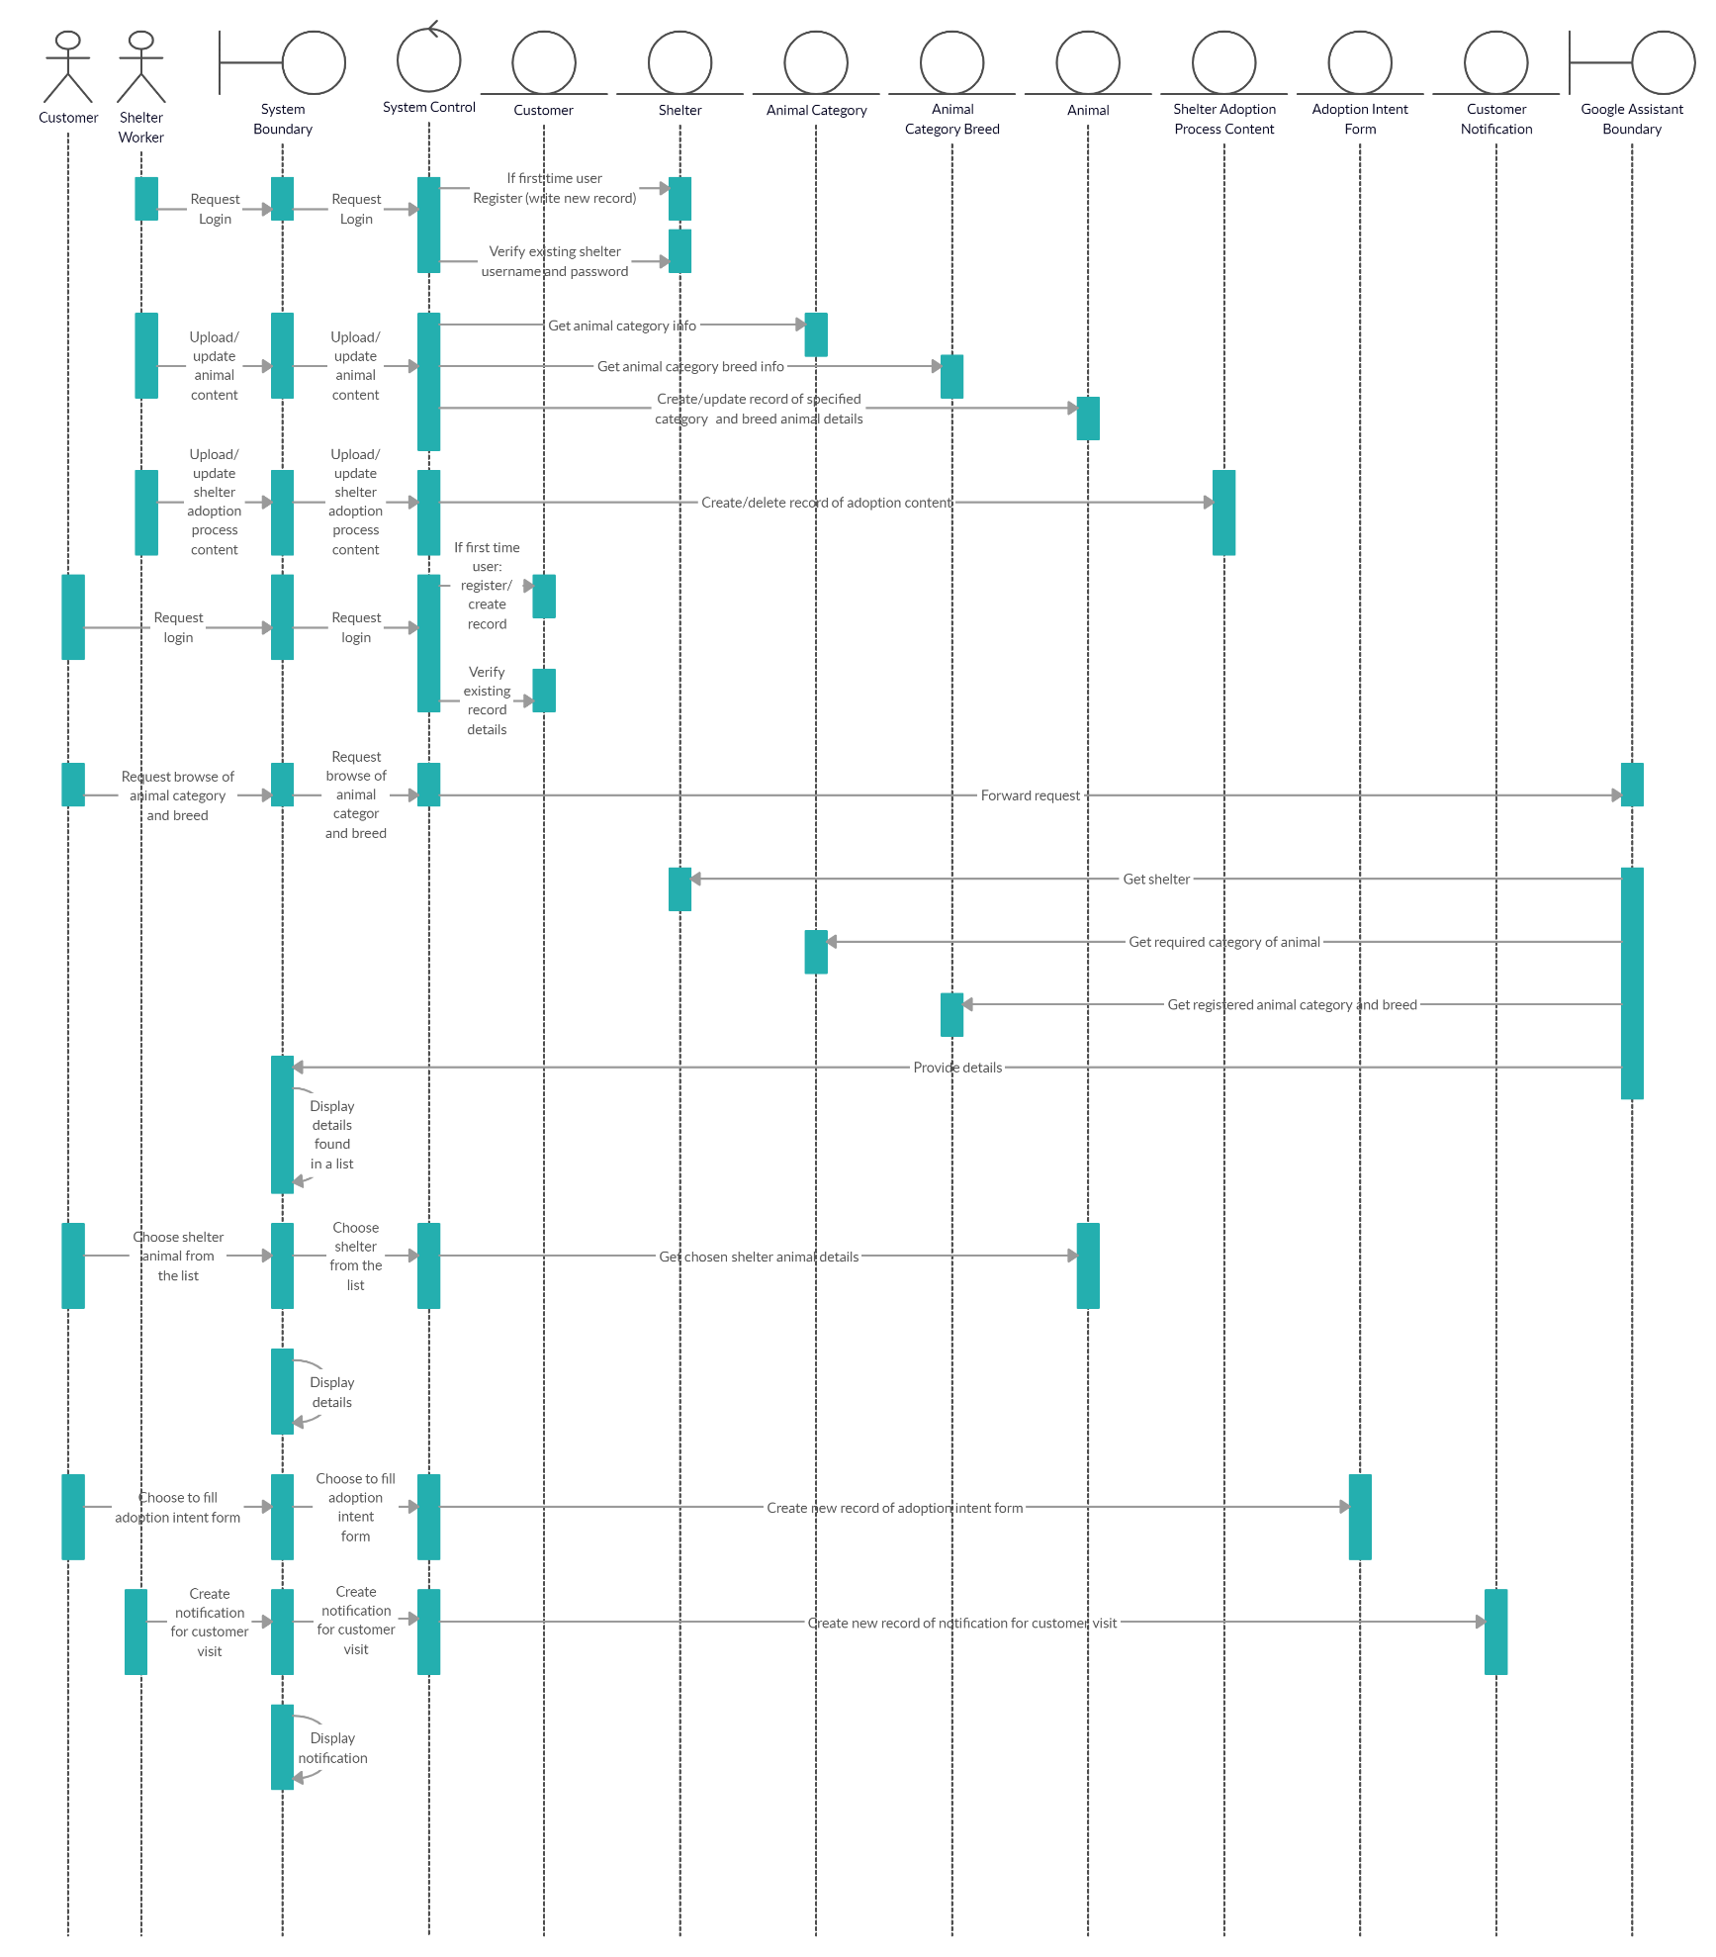

# APPENDIX A7: Object Class Diagram

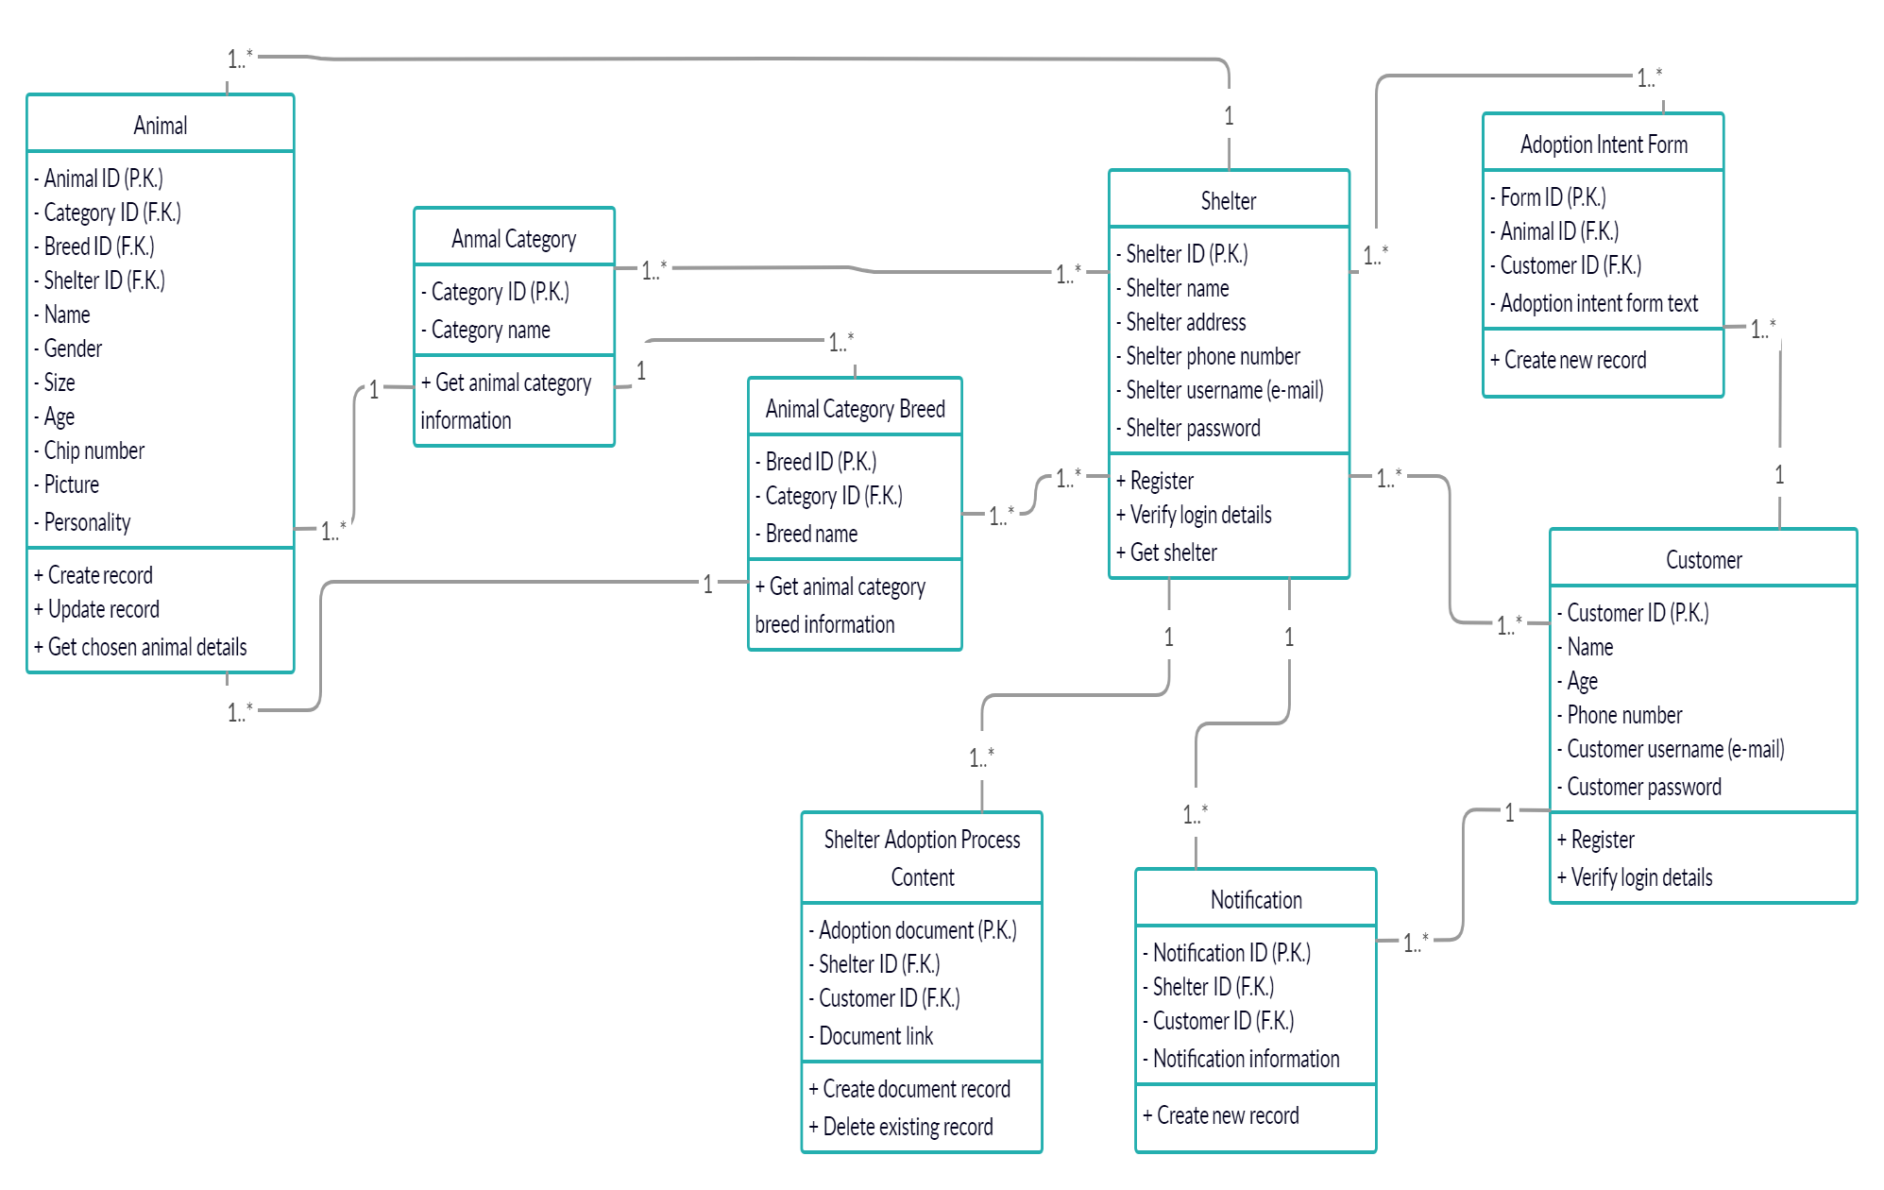

# APPENDIX A8: Graphical Representation of the User Evaluation Survey results

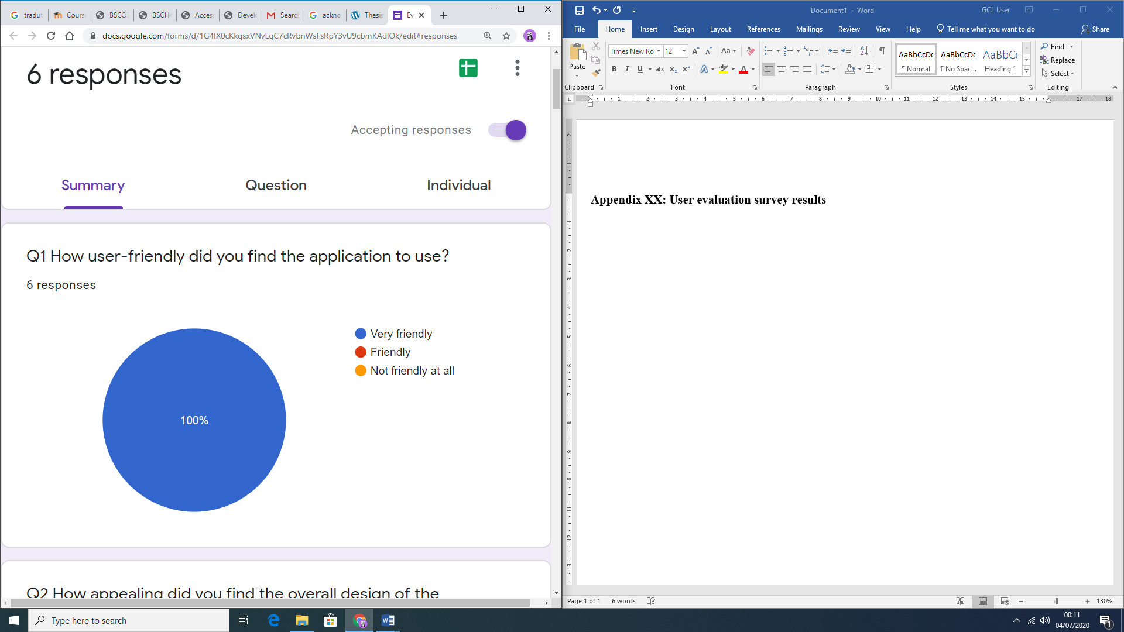

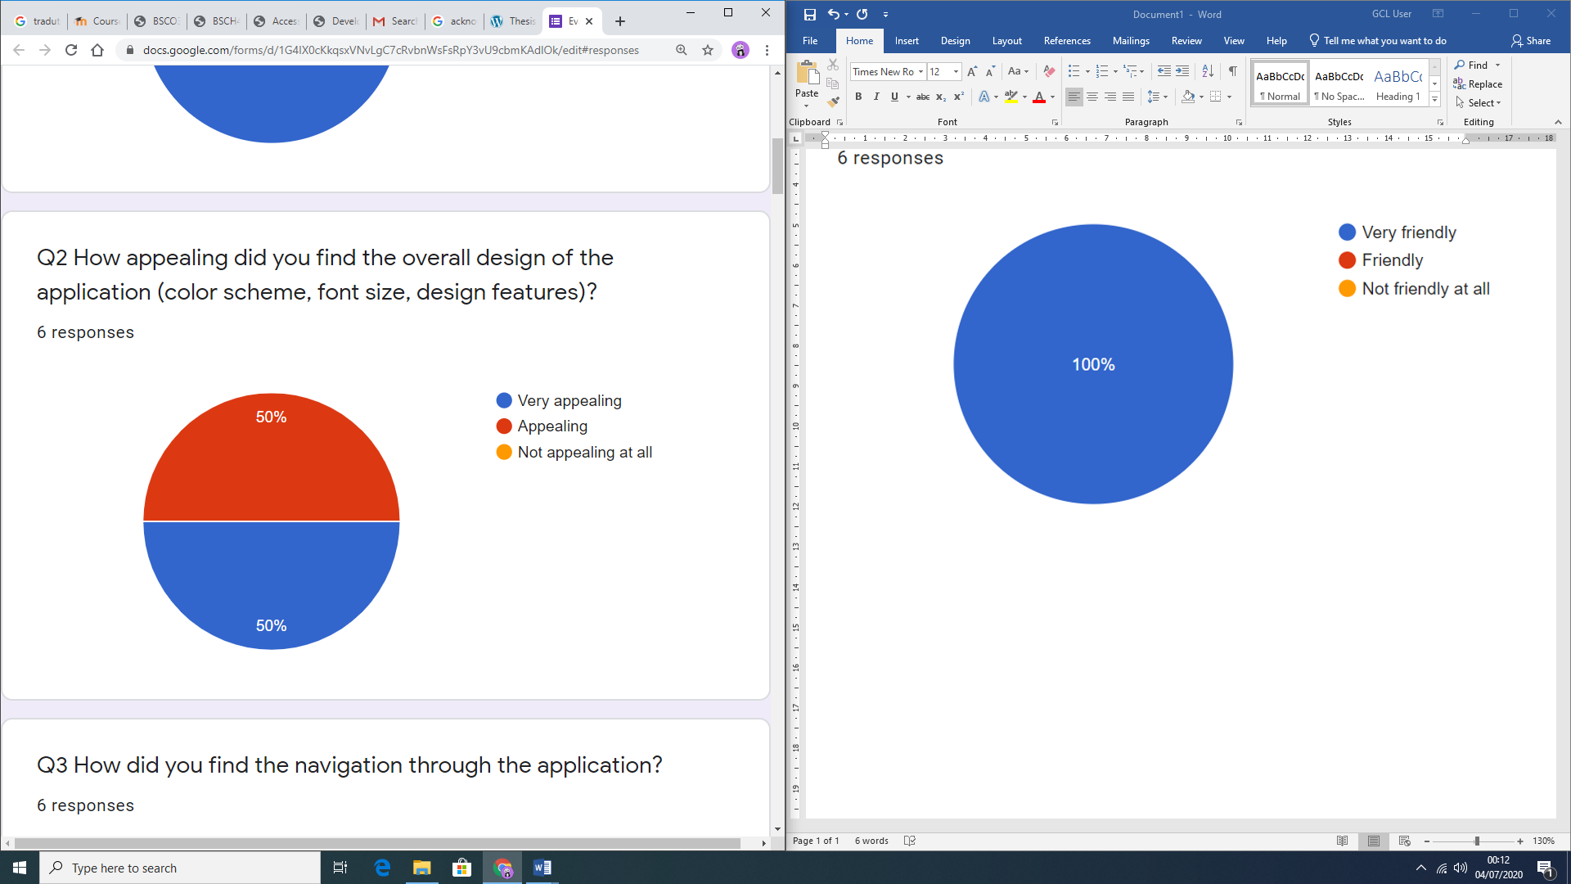

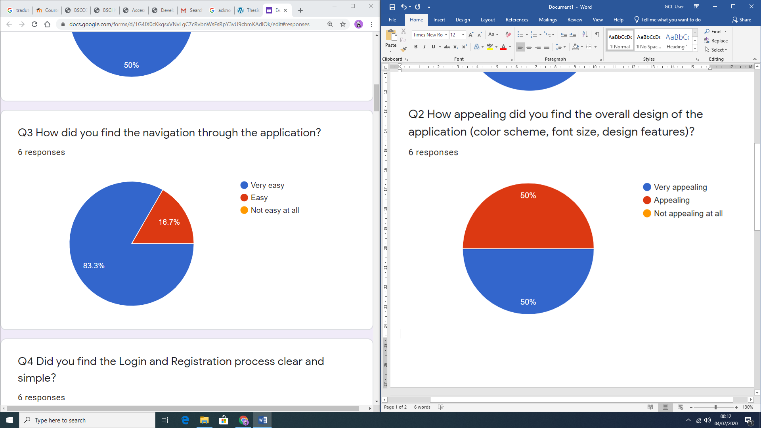

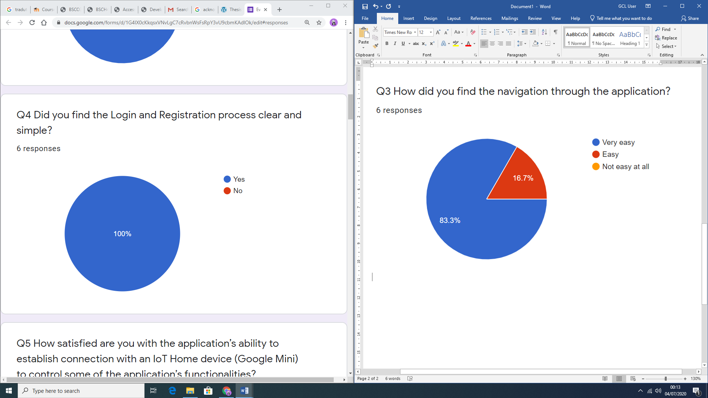

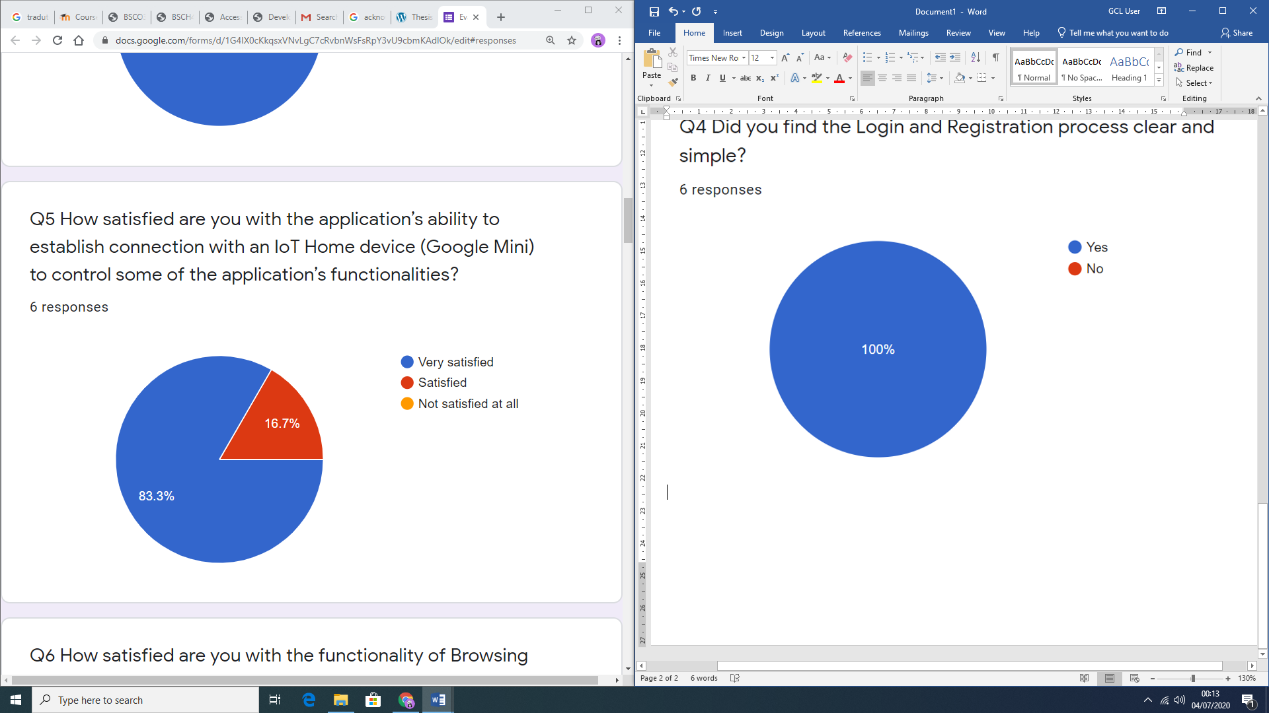

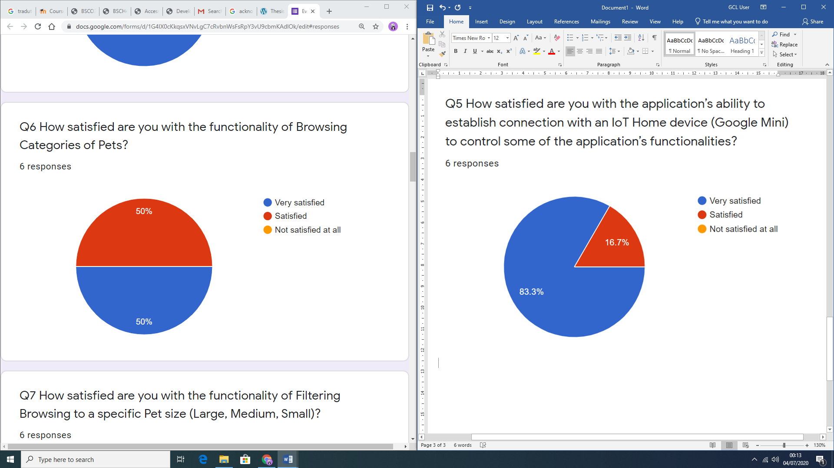

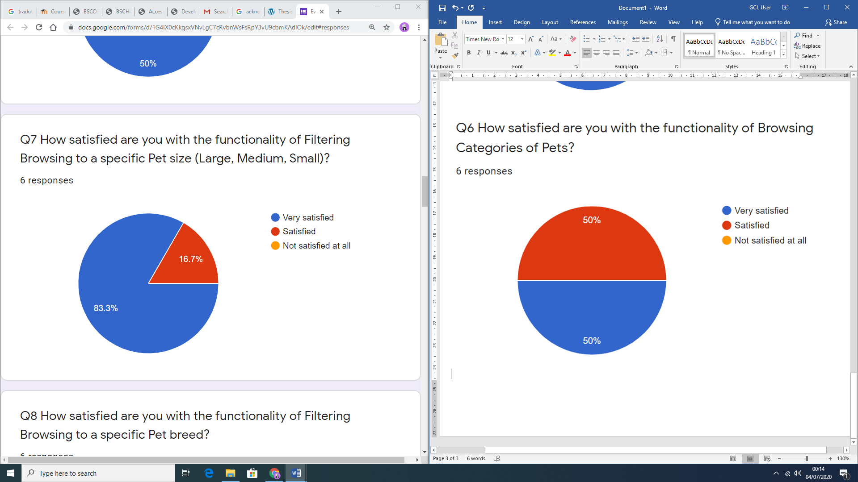

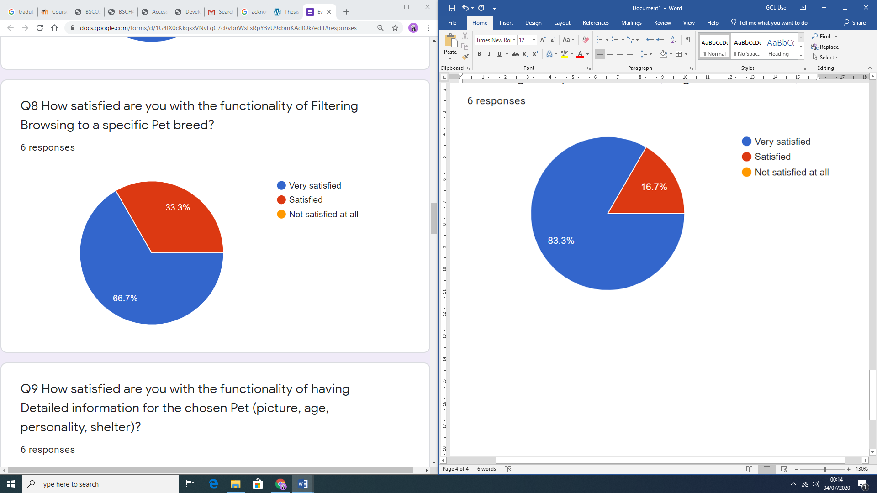

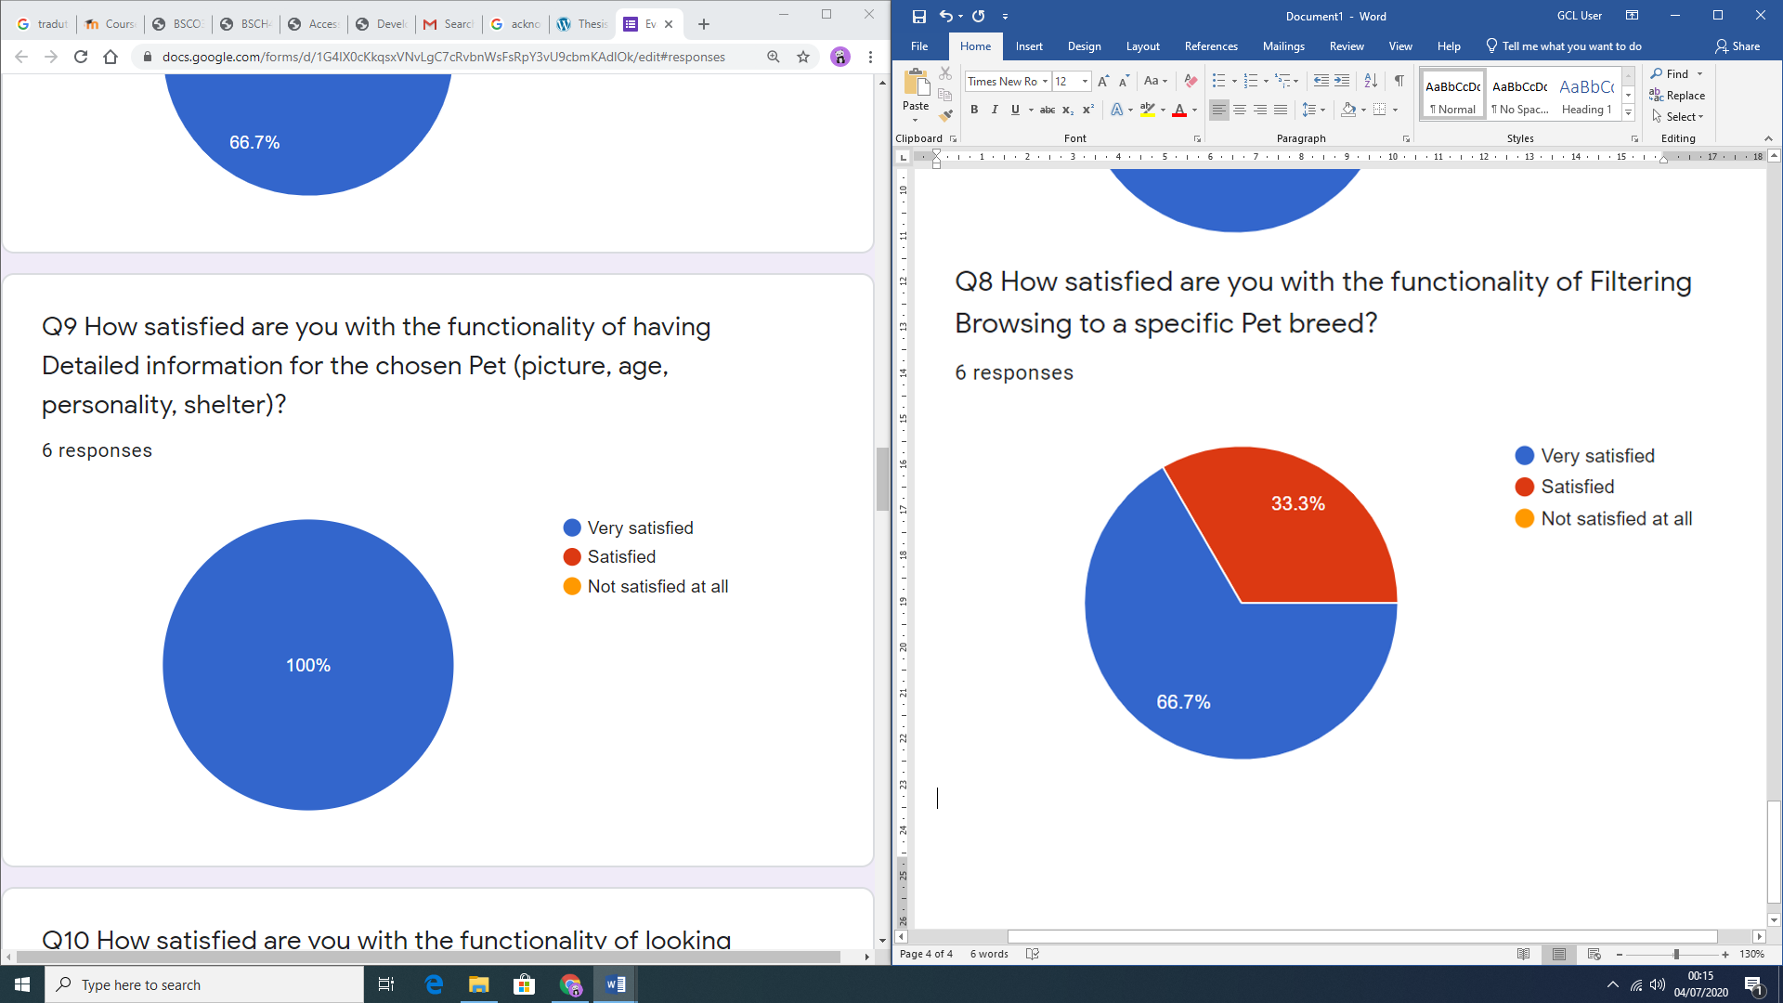

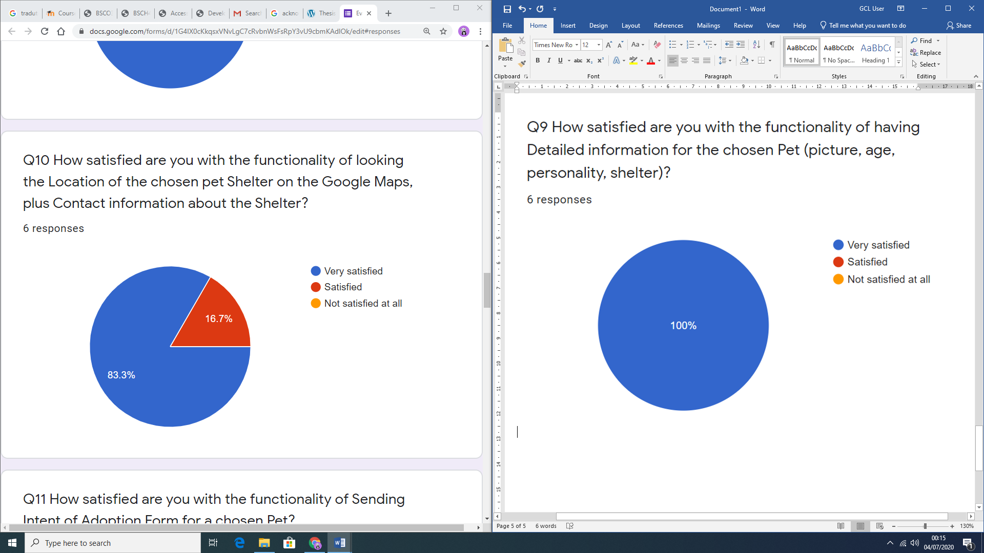

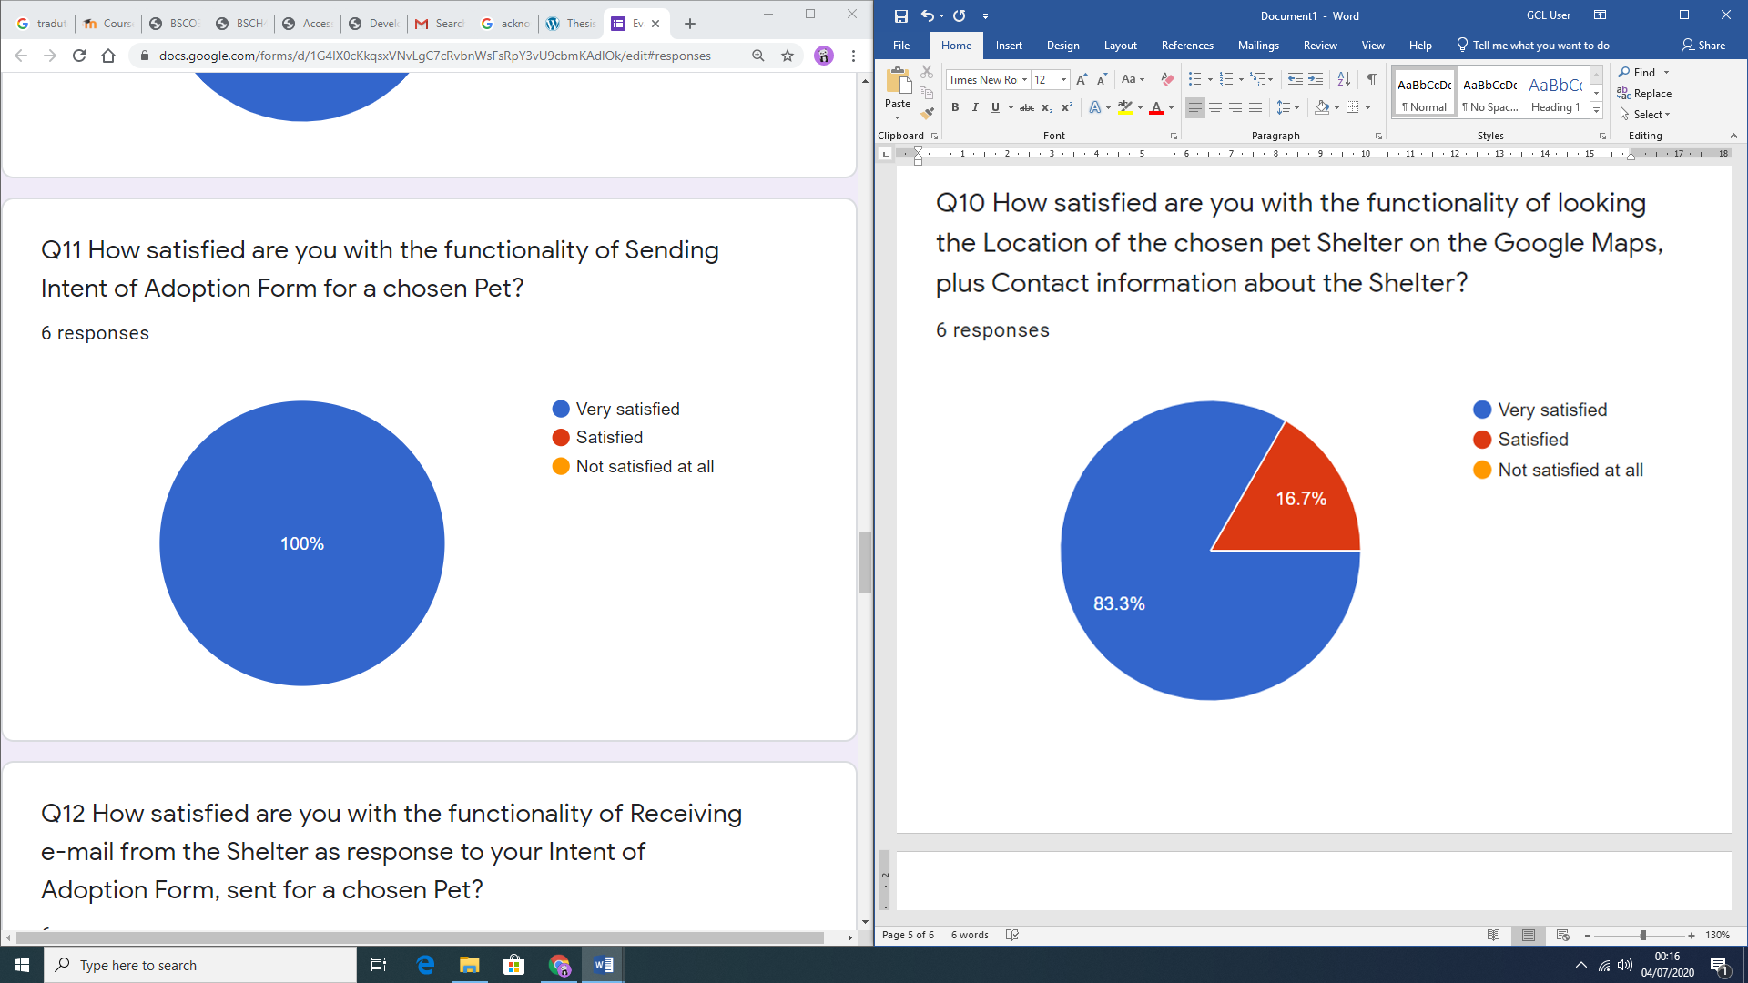

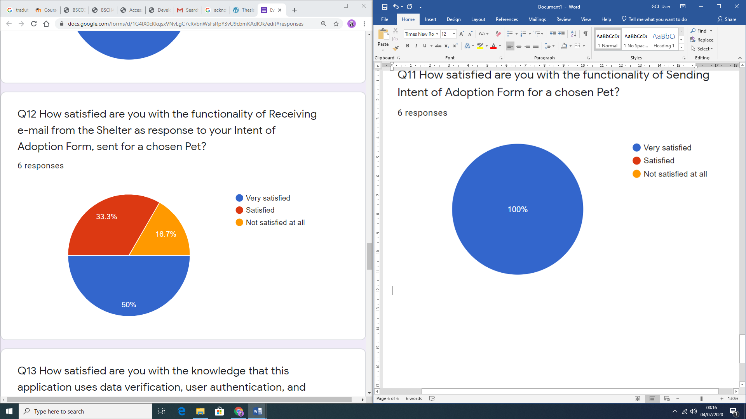

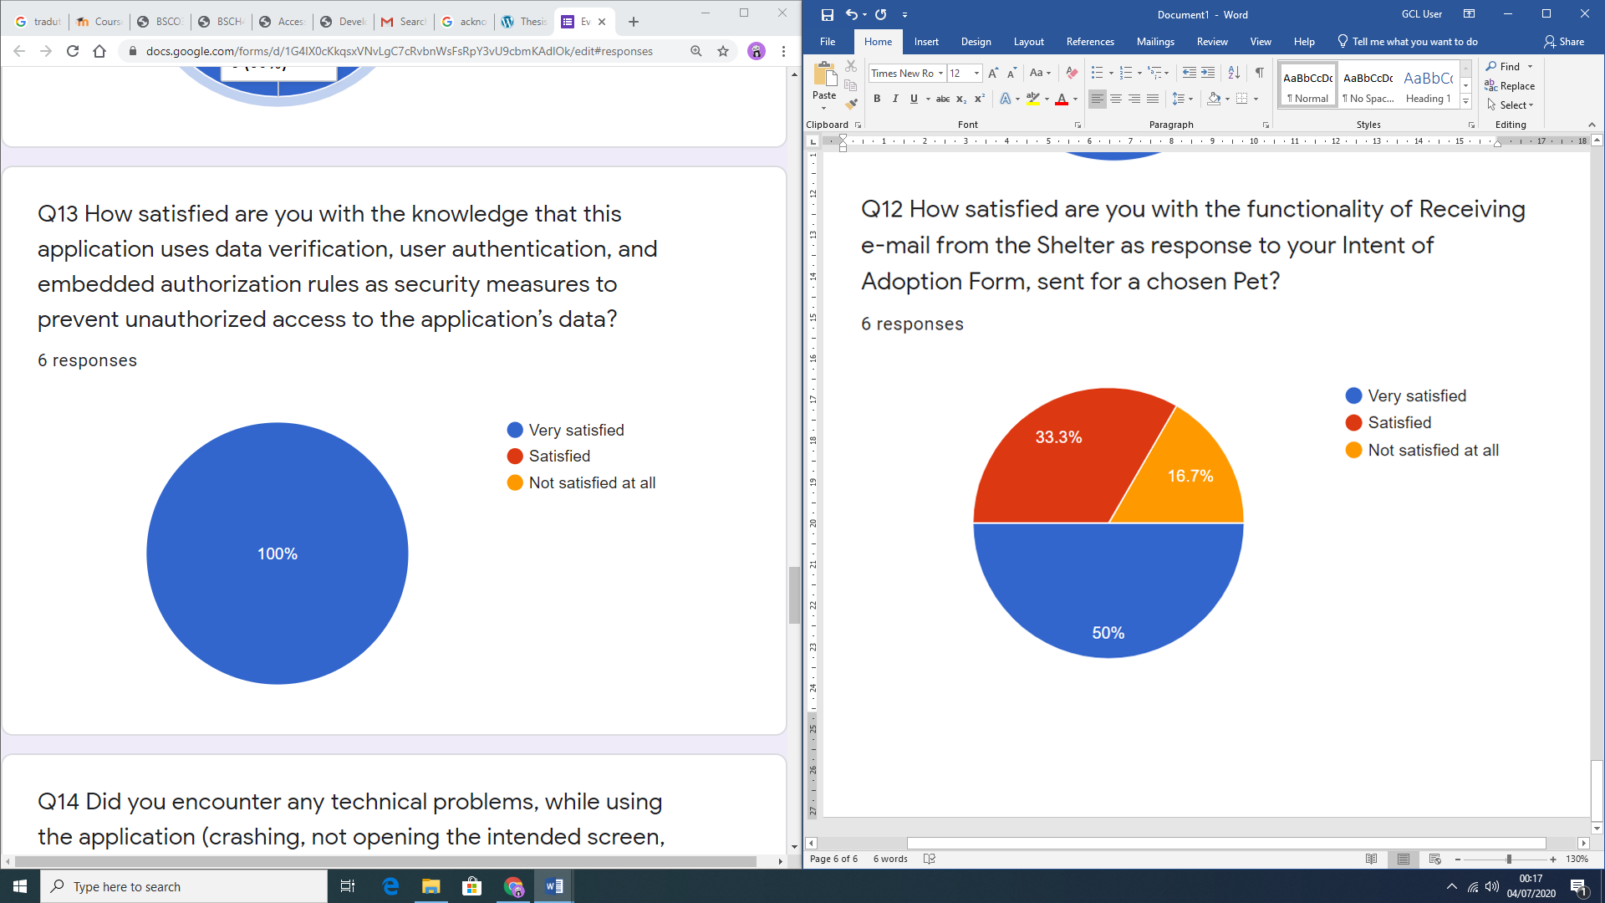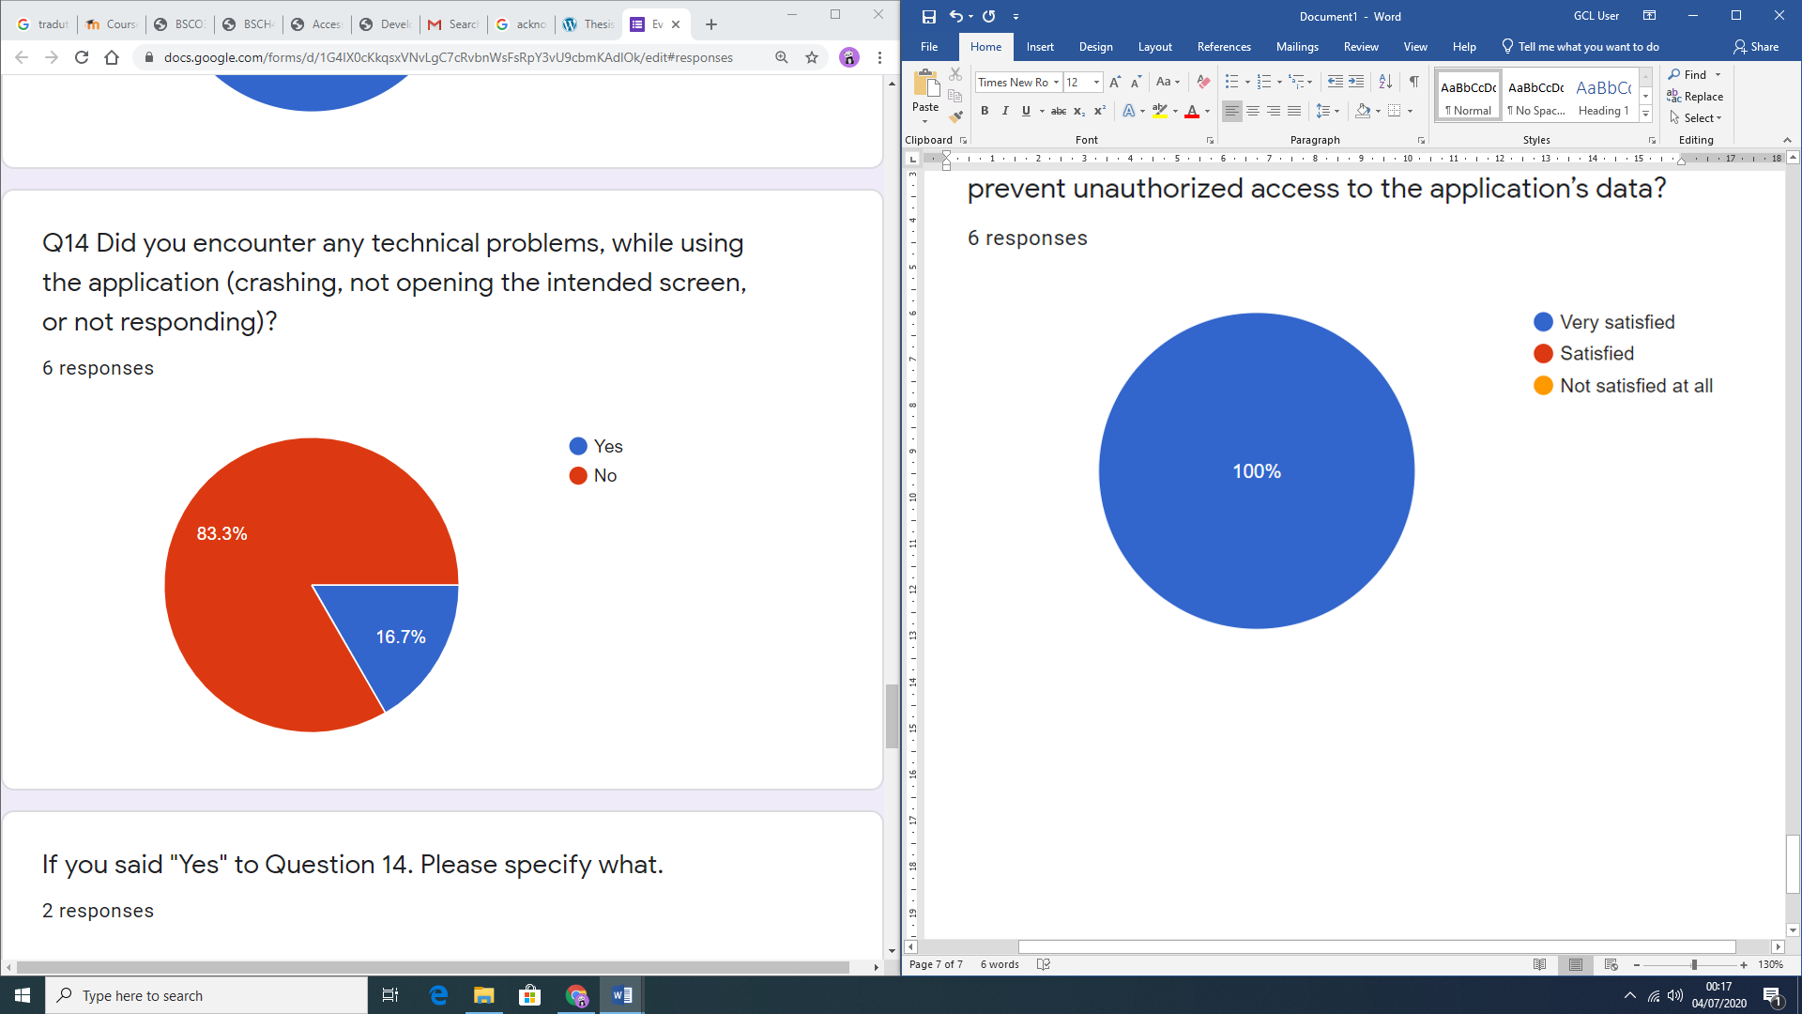

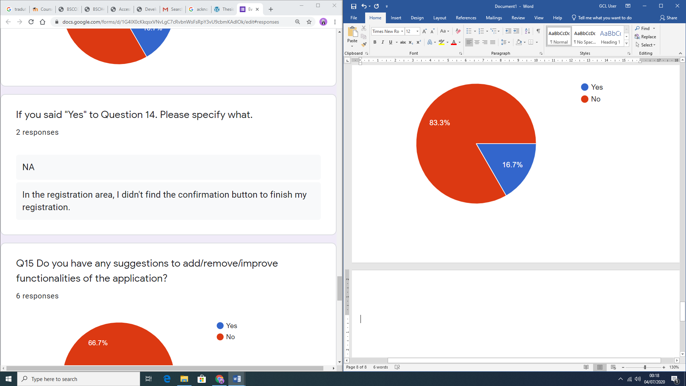

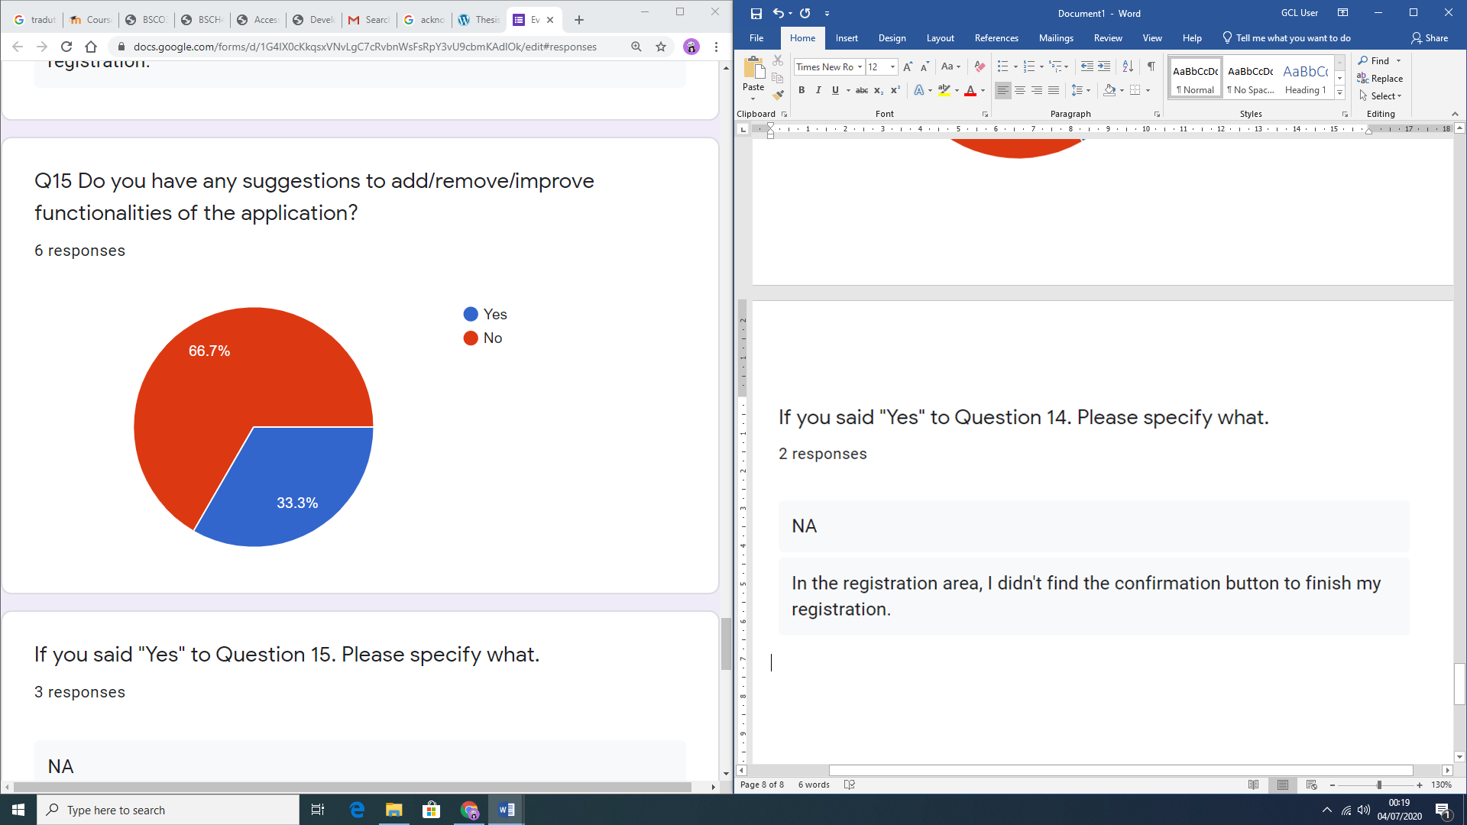

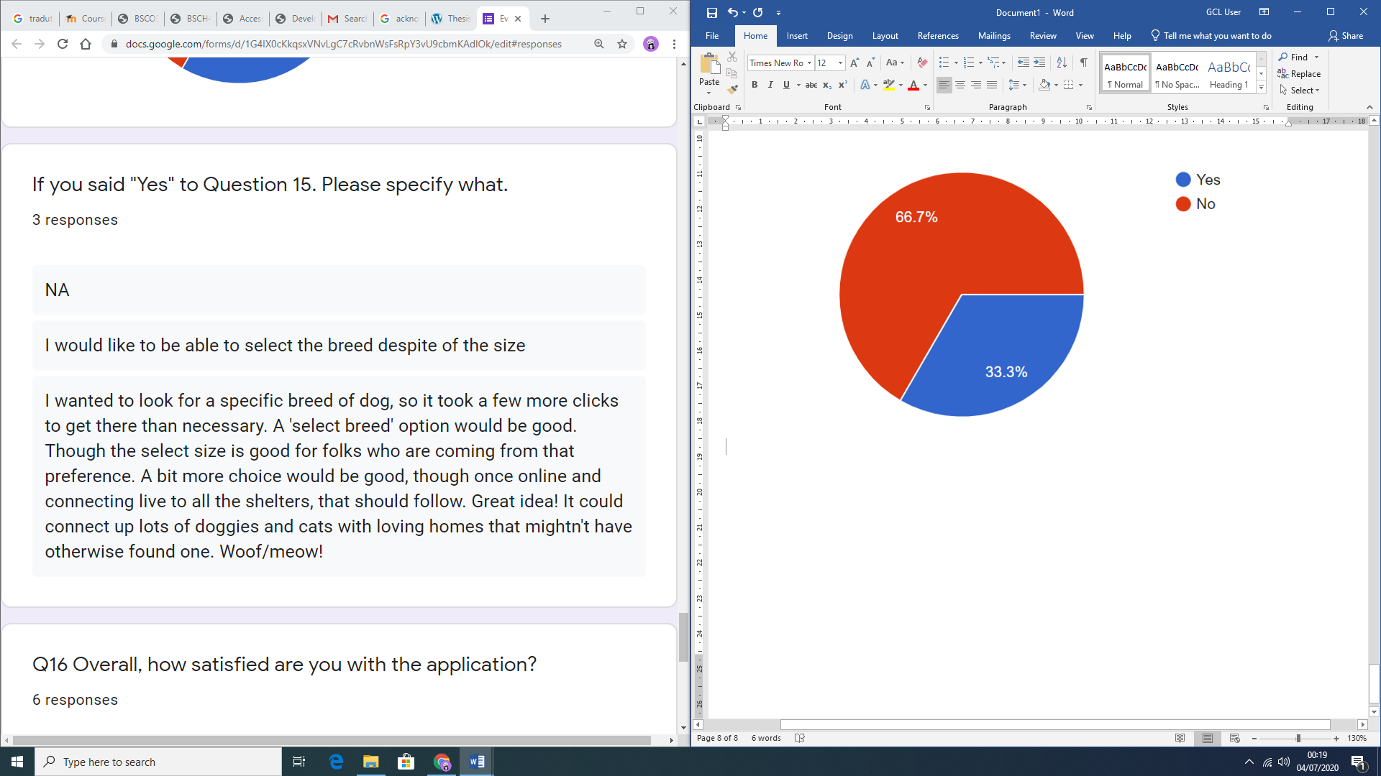

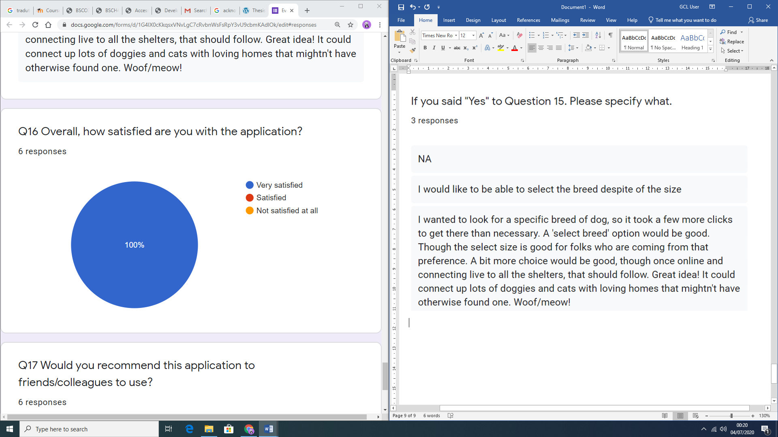

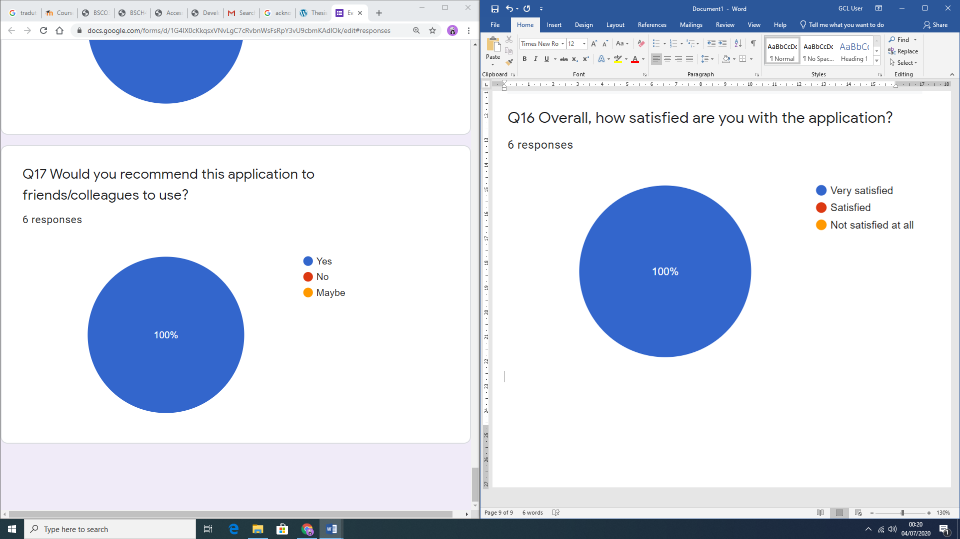

# APPENDIX A9: User Manual

This document has the goal of providing guidance to the user on how to navigate and use the proposed application.

There are two options for using this application: firstly, the user can use the app itself to perform a pet search; secondly, the user can use Voice commands through the Voice User Interface (VUI) of the IoT Home device (e.g. *Google Home*) to do the search. This document starts with explaining first the use of the application itself, and then the use of the VUI is explained.

**On lunch**

When the app is first loaded, users have two options. If have already been registered with the application and consequently logged in, the app will automatically redirect you to the *search screen* in which you can use filters to find suitable pet. However, if the user is not recognized as a registered user, a screen will be presented with options to *login* (in case you have logged out), where you will need to provide valid e-mail address and password, or to *register* (if a first-time user of the app), in which case you need to go through a *Registration* process, as a starting point.

**Login (Sign in)**

The *Login process* requires the typing of the *Username* and the *Password* as provided at the *Registration* process. There is also an option to *Reset your password*, in case it has been forgotten, or to *Register* if you are a first-time user of the application.

**Registration**

The *Registration process* is simple and straightforward. You need to fill out your Name, Mobile number, e-mail address and Password in specified fields on a form, to be registered with the application and have created a profile. Each field has specifications and limits, as well as being mandatory.

As a mobile number, you should provide a valid Irish number, which means starting with 08.

As an email, you should also provide a valid email, which means having the user, the @ symbol and the domain name of the email.

As for the Password, the selected password should be at least 8 characters long, have a mixture of lower- and upper-case letters, digit(s) and at least one special character.

**Updating profile**

With this functionality, you may change specific information within your profile, such as your mobile number, and password. This functionality, when selected, redirects you to a screen, similar with the Registration screen, where the fields for name and e-mail address are locked as unchangeable, since they are considered unique for each person. Thus, only mobile number and password can be modified. This option, as well as *Logout*, only appears when you are already *Logged in*.

**Search Screen**

Within the *Search* screen, you will be able to browse available animals for adoption of specified shelters (which use the application), however, you can use filters to search through the database for a specific type and breed of pet you want to adopt. The filters are nested, which means they are dependent on each other.

Selecting the first filter, you can choose the *Animal Category*, which could be a *cat,* or a *dog*, depending on the existing animal categories in the app’s database.

By selecting the second filter, you can choose the S*ize* of the animal, which could be *small*, *medium,* or *large*.

By selecting the third filter, you can choose the *Breed* of the animal, which is dependent on the filters, previously selected.

After information is being filtered, according to your preferences, you will be able to view in a list all available animals within your selection.

**Pet selected**

When a desired animal is selected from the list, you are redirected to a screen designed to show detailed information for the selected animal. This contains information about:

* Animal’s Name;
* Breed;
* Age;
* Gender;
* Personality;
* Shelter.

**Shelter information**

Still on the *Pet selected* screen, the *Shelter* field, where the animal is located, is clickable and brings the user to a screen with more detailed information for the shelter. This includes:

* Shelter’s Name;
* Phone number;
* Address;
* Email.

It also provides a Google Maps view on the shelter’s location.

**Intent of Adoption**

When you click on the *Send* button next to the selected pet within the *Pet Selected* screen, you will be redirected to the *Intent of Adoption* screen where an email to the Shelter having the pet you want to adopt will be generated, retrieving your user’s name and email, writing an automated email, and sending it to the shelter’s address. After the email is sent, it is up to the shelter to set up an appointment for visiting the shelter to see the pet of your choice.

**Navigation**

The navigation within the entire application is simple and intuitive, proving a menu option button on the top right-hand side corner of the screen for either *updating your profile* or *logging out*, as well as the *filters* for the *search* functionality.

**Voice User Interface (VUI)**

In order for you to use this functionality, you still have to follow the previous steps within the application itself, and you also must be in possession of a Smart Home device, such as *Google Home*.

To activate the application and the database within it, you must say “*Hey Google, talk to Pet Adoption App*”.

After activating the application, you will be welcomed, and able to express your desire. For example:

“I would like to adopt a pet.”

“I would like to adopt a dog”

“I would like to adopt a cat”

“I would like to adopt a small dog”

“I would like to adopt a medium cat”

“I would like to adopt a large dog”

After saying what you want, you will be prompted to answer a few follow-up questions, such as:

“Would you like to adopt a cat, or a dog?”

“What animal size are you looking for: small, medium or large?”

“Here are the breeds we found: *Labrador*, *Dalmatian*. What Breed would you like to see?”

After answering all prompting questions, you will be provided with the results of the search on a spoken manner and also, the results will be displayed on the Smart Home device screen with the option of seeing the shelter’s information or, in case of using a mobile phone, it will be possible to not only see the shelter’s information but also clicking a button to open the exact shelter location on Google Maps app.